**How to 3D-Print**

**at George School**

**2nd Edition**

# Contents

Contents 1

SketchUp Setup 2

Playing Around with SketchUp Tools 2

Your First REAL SketchUp Design **Error! Bookmark not defined.**

Repetier Host Software Instructions 11

Prusa i3 Printer Instructions 22

MakerBot Software Instructions 23

MakerBot Replicator 2 Instructions 27

Appendix A: SketchUp Hints 27

Appendix B: Repetier Host Settings 35

*Important* Printer Settings: 35

*Important* Slicer CONFIGURATION Settings: 38

Appendix C: MakerBot Settings 44

*Important* MakerBot Settings: 44

# SketchUp Setup

1. Grab a mouse from the back of the room.
2. Download SketchUp Make. (It’s free.) <http://www.sketchup.com/products/sketchup-make>
3. Open SketchUp and chose the **Woodworking Millimeters** template.
   1. **View >> Toolbars:** Large Tool Set, Measurements, Shadows, Views, Styles, Solid Tools (if available)
   2. If you haven’t already done so: **Window >> Preferences >> Template >> Woodworking Millimeters**
   3. If the keyboard shortcuts don’t work: **Window >> Preferences >> Shortcuts >> Reset All**
   4. **Window >> Model Info >> Units >> Precision:** Decimal, 0.00mm
   5. Download the “sketchup-stl-2.1.7.rbz” file from **Canvas >> 3D Printing & CAD Files >> SketchUp Files >> SketchUp Plug-ins**. It is fine to leave the file in your Downloads folder. (Or you can move it to your SketchUp folder.)
   6. Install the **SketchUp to STL extension**:
      1. If you have SketchUp 2017 or newer:
         1. From the SketchUp menu bar choose **Window >> Extension Manager >> Install Extension**.
      2. If you have SketchUp 2016 or older:
         1. From the SketchUp menu bar choose **Window >> Preferences >> Extensions >> Install Extension**.
      3. Then search for and select the “sketchup-stl-2.1.7.rbz” file that you just downloaded.
      4. You are now ready to use SketchUp!

# Playing Around with SketchUp Tools

* **Play with some of the tools:**
  1. [R] – **Rectangle Tool** (500,500) at the origin
  2. [O] - **Orbit Tool** to change view.
  3. [H] - **Hand Tool** to change view.
  4. Scroll wheel of mouse to zoom in and out.
  5. [R] - **Rectangle Tool** (700,400) off of the origin
  6. [C] - **Circle Tool** (200)
  7. [C] - **Circle Tool** (3s) (5s) (8s) (100s)

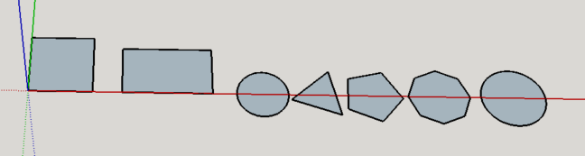

* 1. [T] - **Tape Measure Tool** to find center of the **square**. Three ways to do this:
     + Draw Tape Measure Lines from corner to corner.
     + Because the square is 500mm x 500mm, drag Tape Measure 250mm from top and side edges.
     + Click on bottom edge with Tape Measure tool, then drag tool along the side. Release button when it snaps to center of the segment.

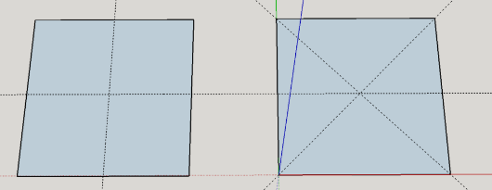

* 1. [C] - **Circle Tool** to place circle (radius = 200mm) at the center of the square.
  2. [Spacebar] - **Select (Arrow) Tool** to select the area within the center circle. Delete it.
  3. [P] - **Push/Pull Tool** to lift one of the circles 400 mm.
  4. [P] - **Push/Pull Tool** to lift the rectangle 600 mm.
  5. [P] - **Push/Pull Tool** – Double-click on a few other surfaces to *auto-lift* to 600 mm. (It may *auto-drop* them instead.)
  6. [P] - **Push/Pull Tool** – Drag the top of a few surfaces to the height of other objects.

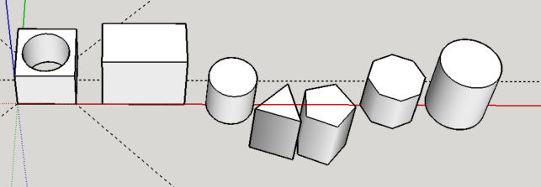

* 1. [R] - **Rectangle Tool** to draw small rectangle on top of one of the objects. Use [P] - **Push/Pull Tool** to lift the small rectangle 150 mm.
  2. [C] - **Circle Tool** to draw circle on the side of the rectangle. Use [P] - **Push/Pull Tool** to **push** the circle **into** the side of the box 50 mm.
  3. [C] - **Circle Tool** to draw another circle on the side of the rectangle. Use [P] - **Push/Pull Tool** to **pull** circle **out** of the side of the box 50 mm.
  4. [C] - **Circle Tool** to draw another circle on the side of the rectangle. Use [P] - **Push/Pull Tool** to cut a circle all the way through the box. You may need to orbit to do this. Stop when the opposite face is gray and white! (See image below left.) Cut more circles to make “Swiss cheese”. Double-click to make easy holes.

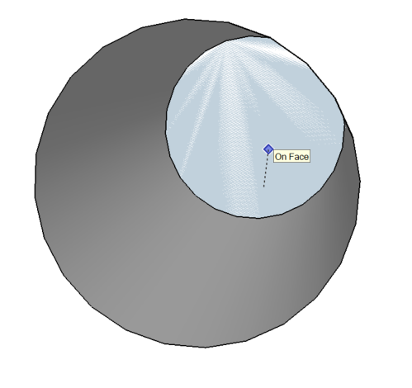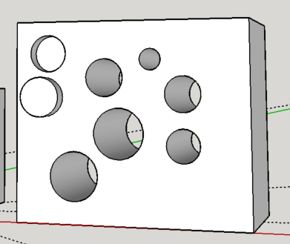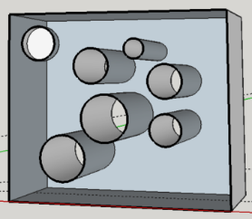

* 1. **Section Plane Tool** to see into the “Swiss cheese” box. (See image above right.)
  2. [Spacebar] - **Select (Arrow) Tool** to select the Section Plane. Delete it.
  3. [T] - **Tape Measure Tool** to score a line 100 mm from the edge of the top face of one of the polygons. Use the [L] - **Line Tool** to draw a line from one edge to another edge along the Tape Measure line. Use [P] - **Push/Pull Tool** to lift the segment 200mm.

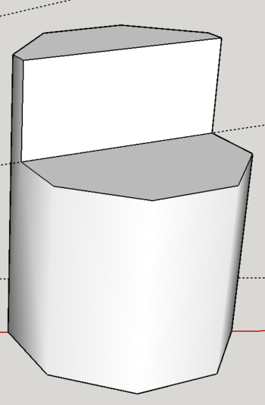

* 1. **Dimension Tool** to show dimensions of some of the objects. (To find height of cylinders, first **View >> Hidden Geometry**.)

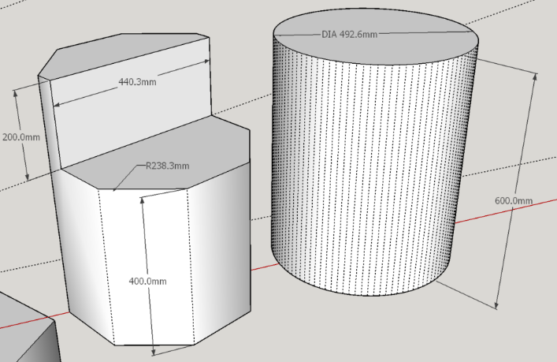

* 1. **Shadow Tool** to change time of day and day of year. (See image above right.)
  2. [E] - **Eraser Tool** to erase part of an object and the Tape Measure lines.
  3. [Spacebar] – **Select (Arrow) Tool** to select some of the objects. Delete them.
  4. Single-click vs double-click vs triple-click on objects and faces.
  5. To place one object on another:
     1. View >> Face Style >> X-Ray
     2. Select Object
     3. Select **Move** tool
     4. Click on point on object you’d like to place on the other object
     5. Click on face/edge/point on 2nd object you’d like to move
  6. To make a **group**:
     1. Select object >> Right-click >> Make Group
     2. A blue box will form around solid object.
     3. When joining objects, best idea is to make them individual groups.
  7. To **rotate** a grouped object:
     + 1. Group the object (see above).
       2. Select **Move** tool and click/drag on the red crosses:

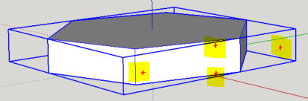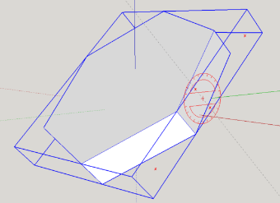

* 1. Use **Section Plane** and/or **X-Ray View** tool to see inside your objects. Very useful when editing!
     1. Can move and rotate the Section Plane like any other plane.
     2. Erase it when done.
     3. See <http://www.youtube.com/watch?v=ZiMA1IAn8HU&safe=active> for nice tutorial.

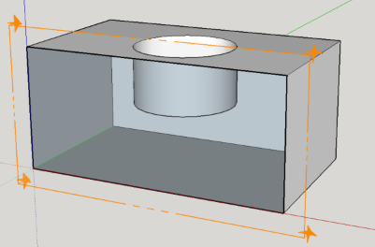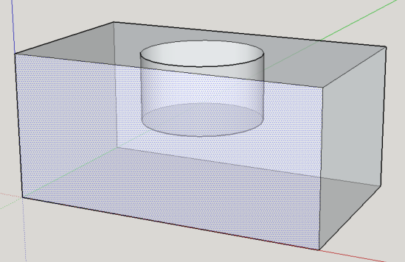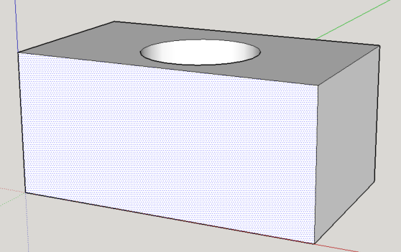

# Design a Nameplate using SketchUp

For this project, you will create a personalized nameplate with the SketchUp CAD program and 3D printer. You will then attach the nameplate toolbox shelves with cable ties. If you have a long name, you may need to use your initials instead. Please use a name that your teacher will recognize as belonging to you. This is a graded assignment, so take your time and ask questions if you are unsure what to do! Follow the steps below

1. Within in your SketchUp folder, create another folder named “**Toolbox Nameplate**”.
2. Create a new sketch (**File >> New**).
3. Save the file in your “Toolbox Nameplate” folder as “***your_Initials*****Toolbox Nameplate**”.
4. Choose one of the following baseplate dimensions based on the length of your name, and make it in SketchUp. You may wish to make them both to see which one is best for your particular name. The two dimensions from which to choose are:
   * + 60mm x 20mm x 2.1mm (for short names and initials)
     + 80mm x 20mm x 2.1mm (for long names)

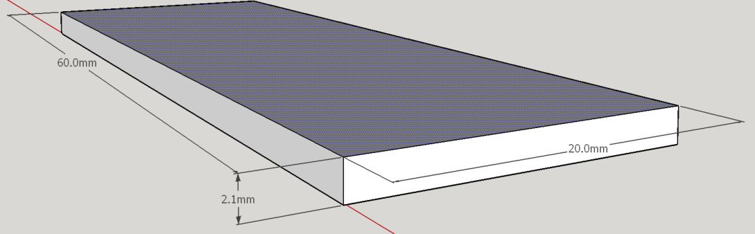

1. Next, make two thru-holes in the top corners of the base plate according to the following guidelines:
   * + The **center** of each hole should be 4.0mm from the sides and 3.0mm from the top edge. Consider using the **Tape Measure Tool** to line up the hole perfectly.
     + The **radius** of each hole should be 2.0mm.

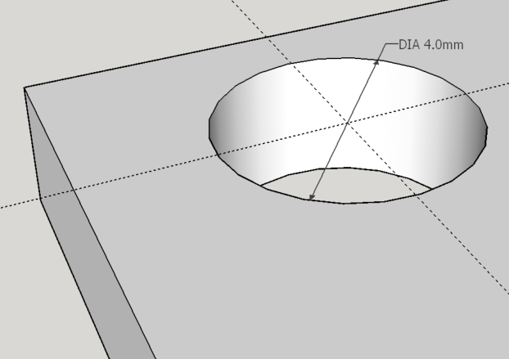

1. To create your name, use the **3D Text Tool** on the Large Tool Set toolbar (see image below). Printing text with a 3D printer can be tricky, as only a few fonts print well. In the interest of time, use the **same settings that are encircled** in the dialog box below. The fields highlighted with yellow arrows should be adjusted according to your name.

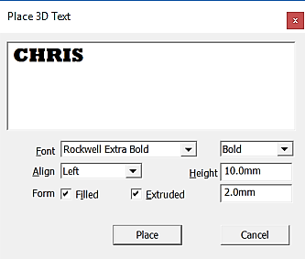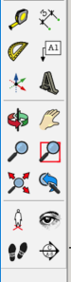

* + - 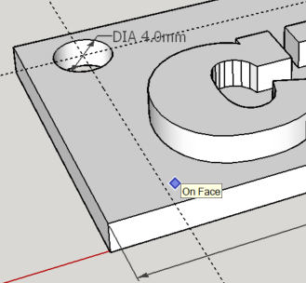To get your name to fit on one of the base plates may take some trial-and-error. Type your name in the textbox as you want it and start with a **Height** of 10mm. Press the **Place button** at the bottom of the dialog box, and then place your name on the **face** of the baseplate. **The following are critical to a successful print:**
      * *When placing your name on the base plate, the words “****On Face****” must appear at your cursor. Only then can you click your mouse to place the name.*
      * *Move your name around so that it is well positioned (i.e., centered) on the plate.*
      * *Your entire name must fit within the confines of the top plate. It must* ***not*** *hang over the edges!*
      * *Your name must* ***not*** *obscure the holes in the corners!*
    - If you want to *increase* the size of your name, delete the 3D text object and try again. Try raising the **Height** value by 1.0mm.
    - If your name is too large, delete 3D text object and try again. Try lowering the **Height** value by 1.0mm and/or try using all lower case letters to save space. Do not make the height too small, or it will be difficult to read. (Try to keep your lettering height to at least 6mm or 7mm.) If your name is still too long, you may need to use your initials.
    - You can move your 3D name around with the **Move Tool**.

# Export the SketchUp (*SKP) File as a Stereolithography (*.STL) File

Once you are happy with the positioning of your object on the virtual base plate, you are ready to export your SketchUp (*.SKP) file as a **stereolithography (*.STL)** file, which can be 3D-printed! To do so, follow these steps:

1. If you have already installed the SketchUp STL Extension….
   1. Use the **Select (Arrow) Tool** to draw a box around the objects you want printed. This will select all components and highlight them blue, like so:

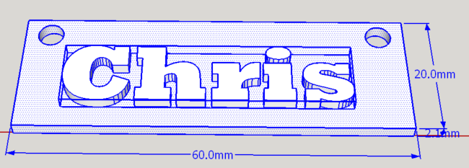

* 1. From the SketchUP menu bar, select **File >> Export STL …**. (Note this is **not** File >> Export! Rather, select **File >> Export STL…**). (If this is not an option, you need to install the SketchUp STL Extension, as explained below.)
     1. In the dialog box that opens, place a check in the box that says, “*Export only current selection*” and then press the **Export button**.

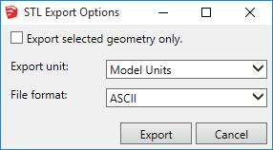

* + 1. Use the Model Units and ASCII defaults.
    2. Save the file as “***your_Name******objectName*.STL**” in your SketchUp folder. Be sure the “.STL” extension is included!
  1. You are now ready to prepare the *.STL file for 3D printing using either the **MakerBot Desktop** or **Repetier Host** software. See the next sections on how to do this.

1. If you have not installed the SketchUp STL Extension, you must do so now, and then return to the above steps. If this is your **first time** to install the STL extension, do the following:
   1. Open SketchUp
   2. Select **Window >> Extension Warehouse**
   3. In the window that opens, search for “STL”, like so:

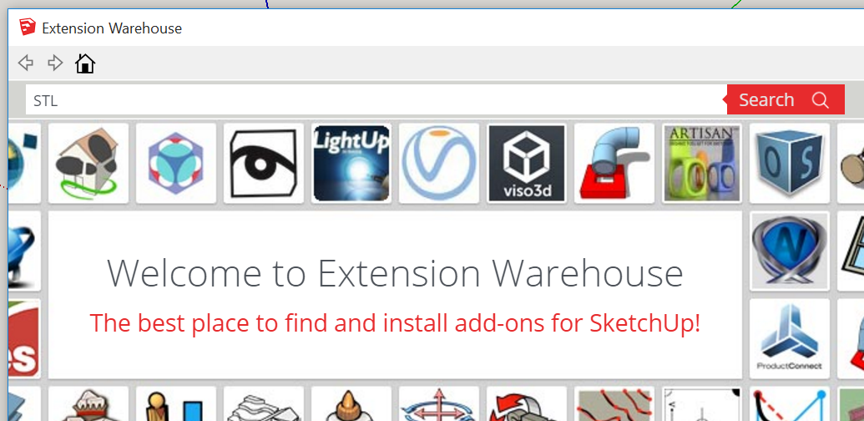

* 1. Select the **SketchUp STL Extension:**

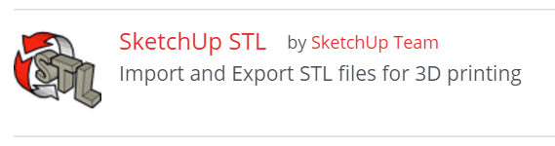

* 1. In the window that opens, press the **Download button**:

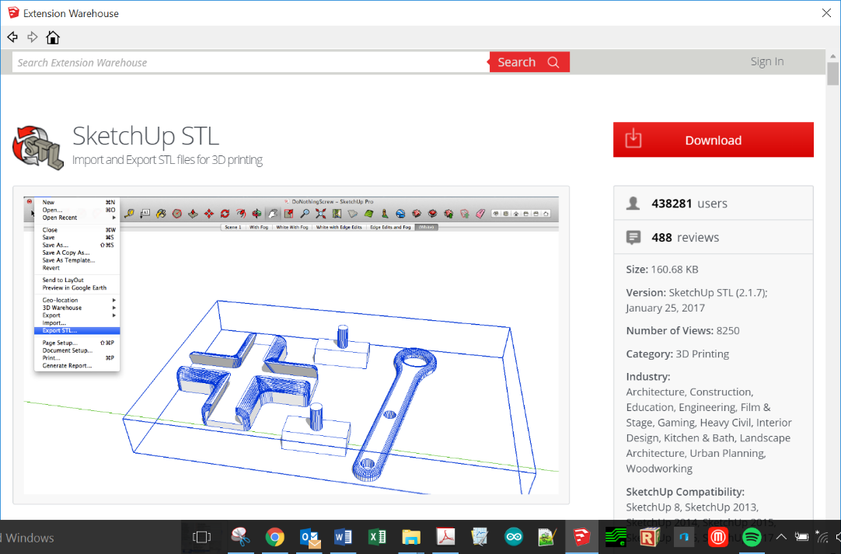

* 1. After logging in, press the **Install button**:

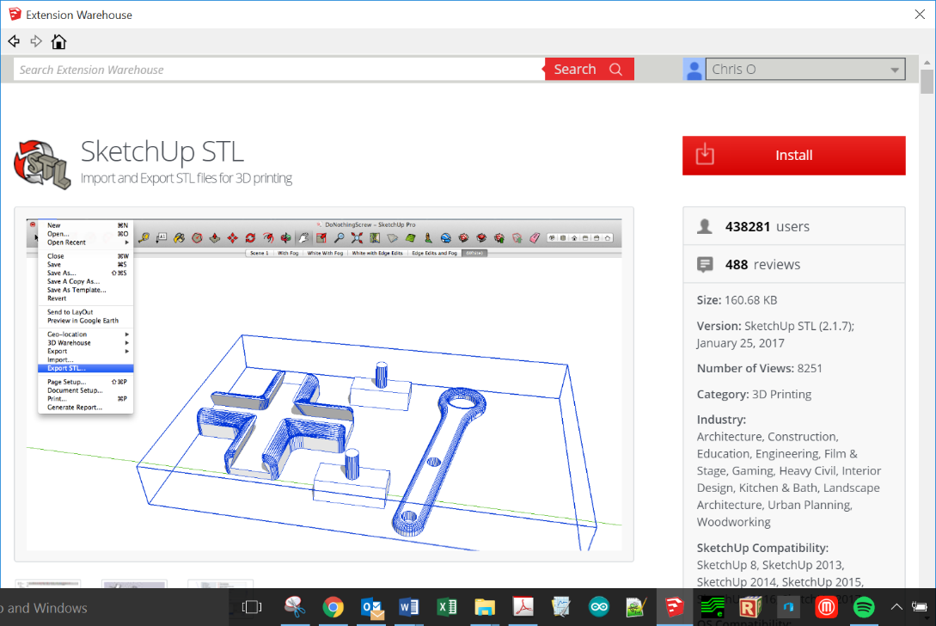

* + 1. Once the extension is installed, you may want to locate the Ruby (rbz) file so that others (i.e., students) can download it without having to log in. (See Step b. immediately below!) The location all the SketchUp extensions are found here:
       1. Windows:

C:\Users\YOUR USERNAME\AppData\Roaming\SketchUp\SketchUp 2017\SketchUp\Plugins

* + - 1. Mac OSX: Version 2013 and newer: Open a new Finder window, press and hold the Option key on your keyboard, the click **Go** in the menu bar **> Library > Application Support > SketchUp # > SketchUp > Plugins**

Mac users need to pay particular attention here, as it is a common misconception that the plugins folder is located with the SketchUp package.

**A note about *.rb files:**

* .rbz is a .rb file that is zipped and the .zip extension is changed to .rbz this allows you to install .rbz files from the preferences panel to install .rb files you need to place those in your plugins folder manually .rbz works in both the Free and Pro version of SketchUp
* If you prefer the .rbz way, you can always right click on an .rb file and send it to a ZIP file then rename the ZIP extension to .rbz and you can use the preferences installing way. Similarly, if you have a ZIP'ed plugin already, just rename the extension.
  1. If you have downloaded the STL extension before, and have access to the STL Ruby file (see above point -- it will look something like “sketchup-stl-2.1.4.rbz”), you can install the STL extension, by doing the following:
     1. For SU 2017 and beyond, select **Window >> Extension Manager** and press the **Install Extensions button** (see below). For older versions, select **Window >> Extension Manager >> Extensions**.

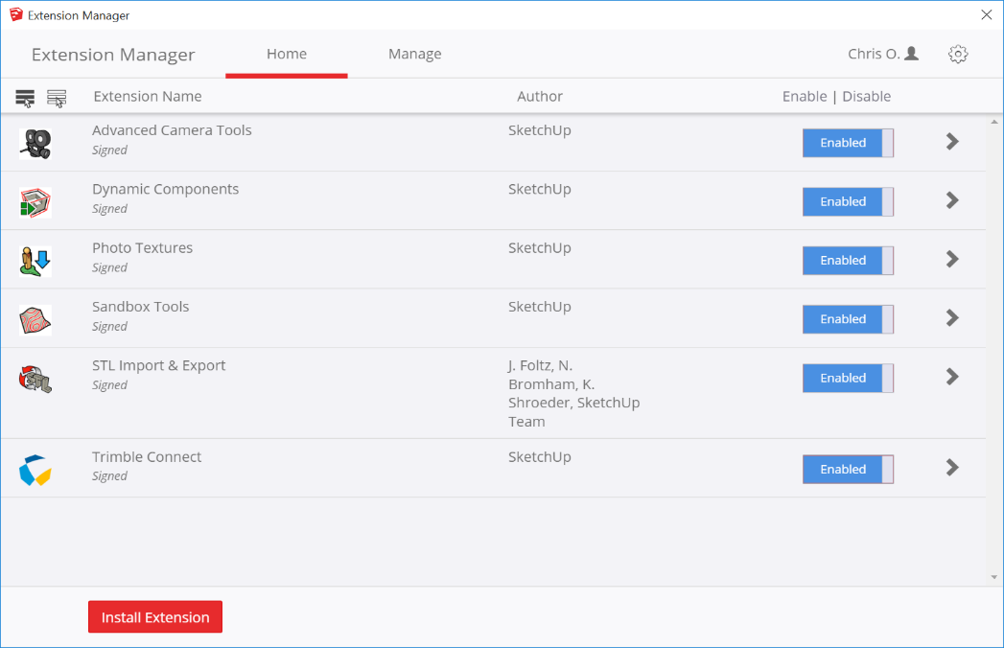

* + 1. Locate the Ruby file and install it.
    2. You may need to restart SketchUp for the extension to appear in the menu. (See below.)

# Repetier Host Software Instructions

## Install and Configure the Repetier Host Software

1. If you are not using a GS laptop, you must download the Repetier Software @ <https://www.repetier.com/download-now/>
2. Download the **Repetier configuration file** from Canvas and place it in your 3D printer folder on your computer. The file is here: **Files >> 3D Printing & CAD >> Repetier Files >> GS Prusa config bundle.ini**.
3. Open the Repetier software.
4. If this is the first time to open Repetier, you may see a **setup wizard** that asks you to enter some settings for your particular printer. Enter or change the following data, which are good for the GS printers:
   * G-code flavor = RepRap
   * Bed size = x: 220, y: 220
   * Nozzle diameter = 0.40 mm
   * Filament diameter = 1.75 mm
   * Extrusion Temperature = 200 C
   * Bed temperature = 60 C

## Load the STL File into the Repetier Host Software

1. Most of the time, you will print using the SD card option; if so, skip to the next step. However, if you want to print in real-time with your computer connected to the 3D Printer, plug in the USB cable and press the **Connect button** (see below). Otherwise skip to next step.

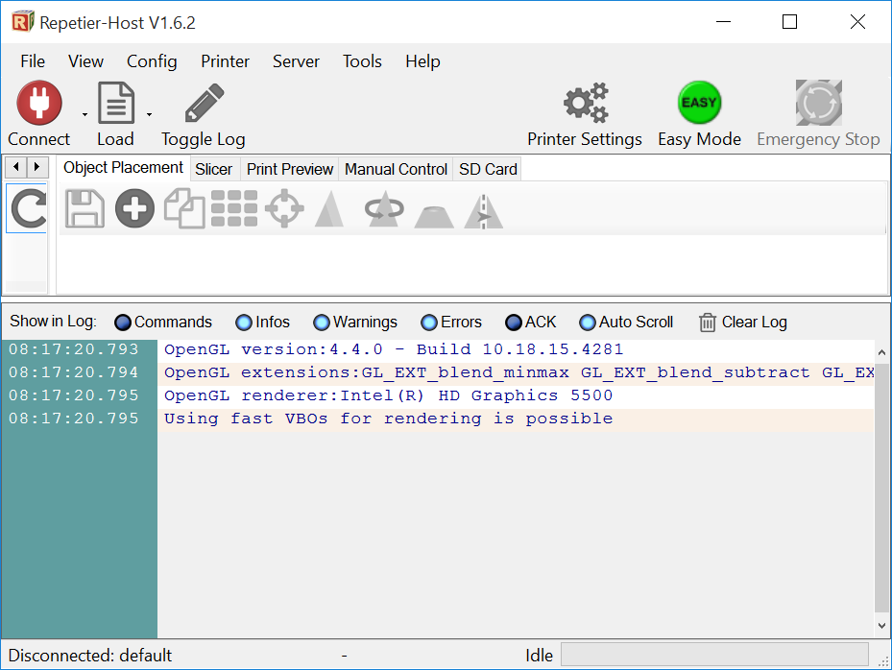

1. Load the STL object files that you wish to print by clicking on the **Load button** and selecting your STL file. Place your object on the Repetier Host’s virtual deck by clicking on the **Load button** on the top ribbon bar, or the **Add Object button** under the Object Placement toolbar. Then select the **\*.STL file** that you want to render.



1. Your object will appear on the 3D printer virtual deck, like so (go George School!):

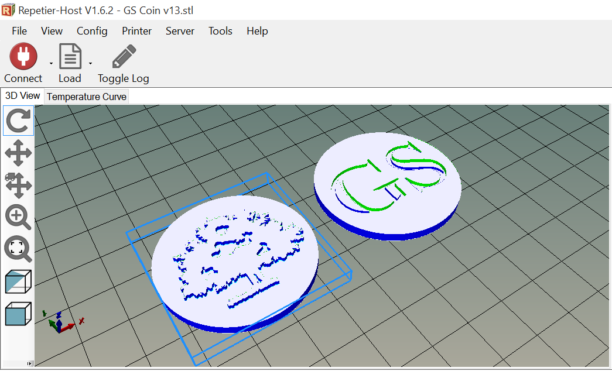

1. If your object is not a **water-tight manifold**, Repetier Host will tell you with a **manifold warning message**! (See the orange warning messages in the image below.)
   * The easiest way to fix the mistake is to press the **Repair Icon** to fix the problem:
   * If you want to repair the hole yourself, you will need to return to SketchUp and repair the hole. (The yellow arrow in the image below shows the gap in the manifold, and the red circle highlights the warning message.) This object must be removed from the deck either by highlighting the object and pressing the **Delete key** on your keyboard or clicking on the trash can, highlighted by the green arrow in the image below. The object can be repaired in SketchUp, and you can try again!

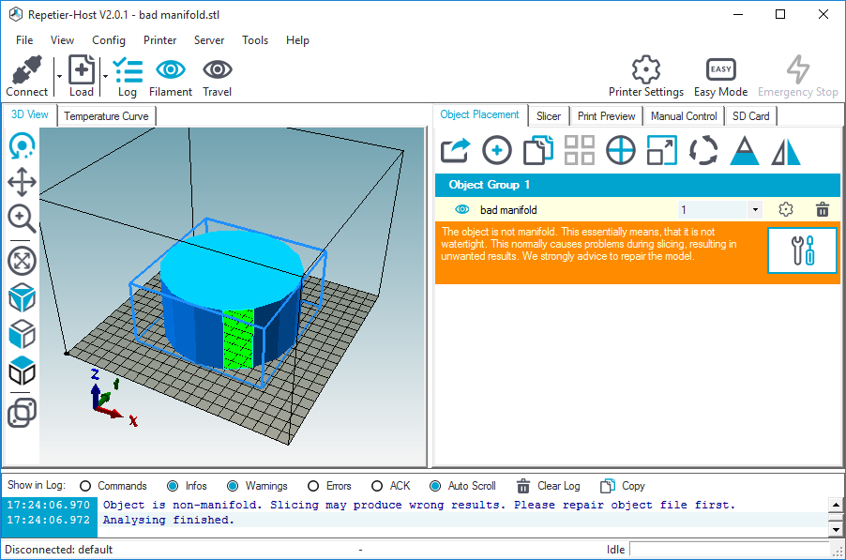

1. You can continue to add other STL objects to the virtual deck that need printing. (It is often faster to print a few a time, rather than one at a time.) Do not over-crowd the deck.

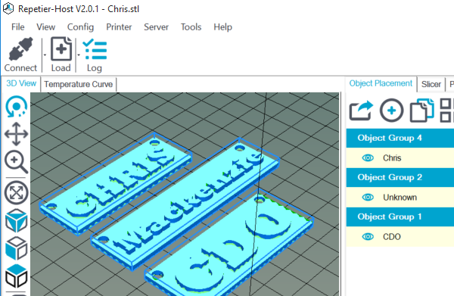

## Change the View of the Objects on the Repetier Virtual Deck (if necessary)

1. It is easy to **change the view** of your object on the virtual deck. Simply click on the deck and move your mouse around to **rotate** your field of view. Press the **SHIFT key** to **pan** around the deck. **Zoom** in and out with the scroll wheel on your mouse.
2. 3D prints are best done in the center of the print deck, so **move** your object to the center of the virtual deck. There are several ways to do this:
   * Press the **Move Object button** and drag the object around with the mouse.
   * You can **automatically center** the object on the deck by selecting the object and pressing the **Center Object button**, as highlighted in the image below.
   * With your mouse, while pressing the **ALT key** on the keyboard (xxx on a Mac), move the object on the x‑y plane with a click-drag of the mouse.
   * To **pan** your point of view, press the **SHIFT key** while click-dragging the mouse.

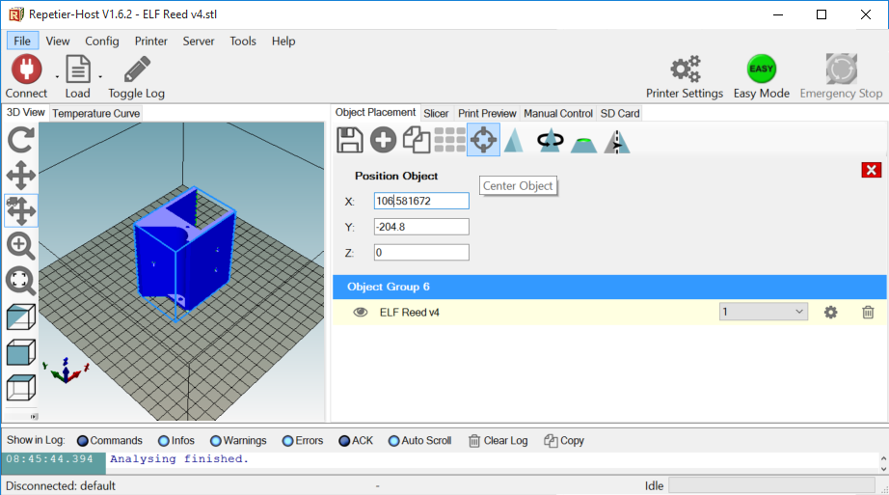

* + Alternatively, you may enter the desired x, y, z coordinates in the Position text boxes. As shown in the image below, (110, 110, 0) are the coordinates for the center of the Prusa i3 RepRap printers. *This is true only if your object was designed at the origin in SketchUp! (E.g., the object in the above image was* ***not*** *drawn at the origin!)*

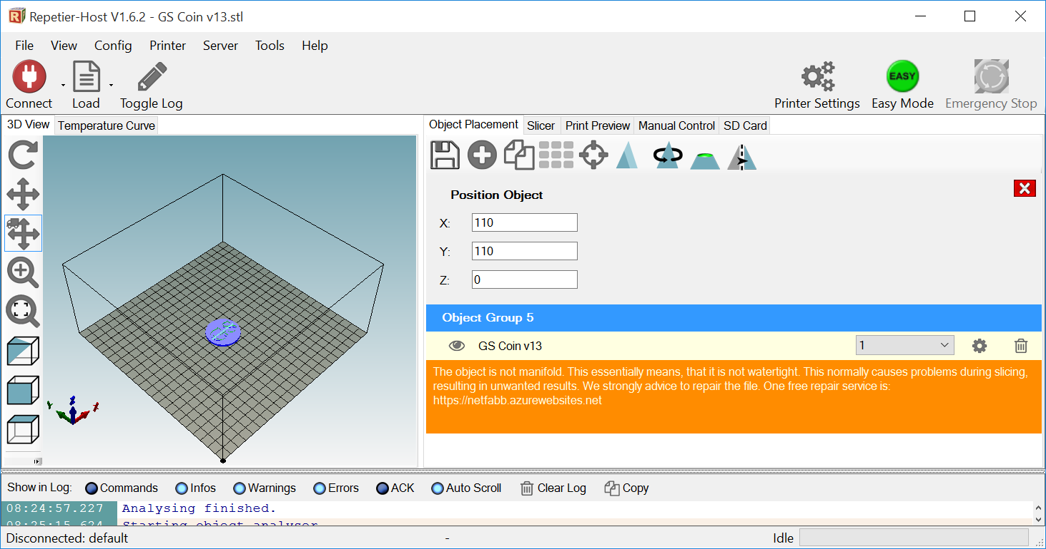

1. Perhaps the most frustrating think about the Repetier Host software is how cumbersome it is to **rotate** your object on the deck. *Therefore, get your orientation correct in SketchUp* ***before*** *you move your object to the Repetier deck!* To rotate the object on the deck, press the **Rotate Object button** and enter the angle(s) about which you want to rotate the object along the x-, y-, and z-axes.
   * The z-axis is the one you will probably use most often, as it serves to spin the object on the deck surface.
   * Also, experiment by rotating in multiples of 90° increments.
   * Use the x-, y-, z-axis legend in the bottom left corner of the scree to help your orientate the deck.
   * See the images below for examples of a variety of rotations.

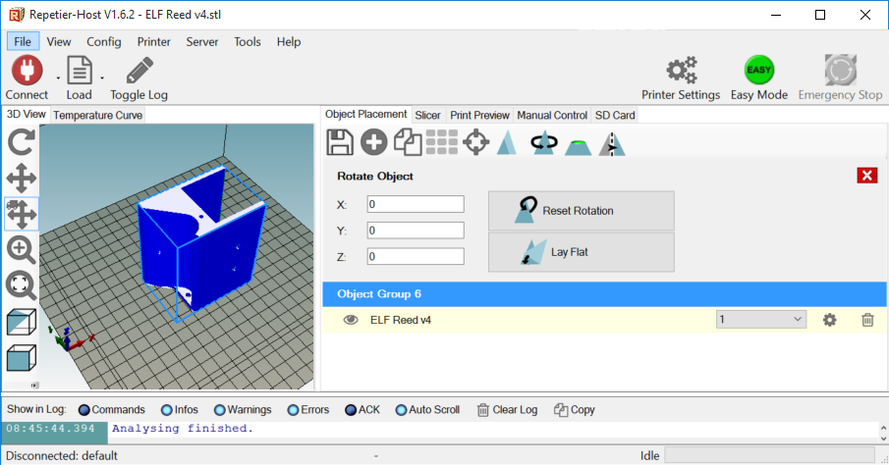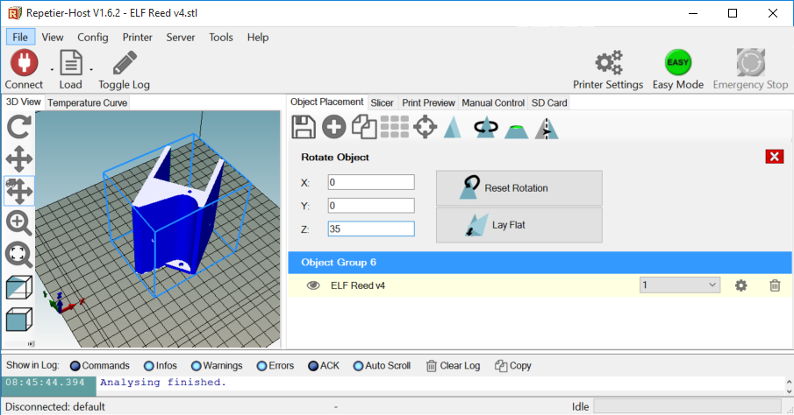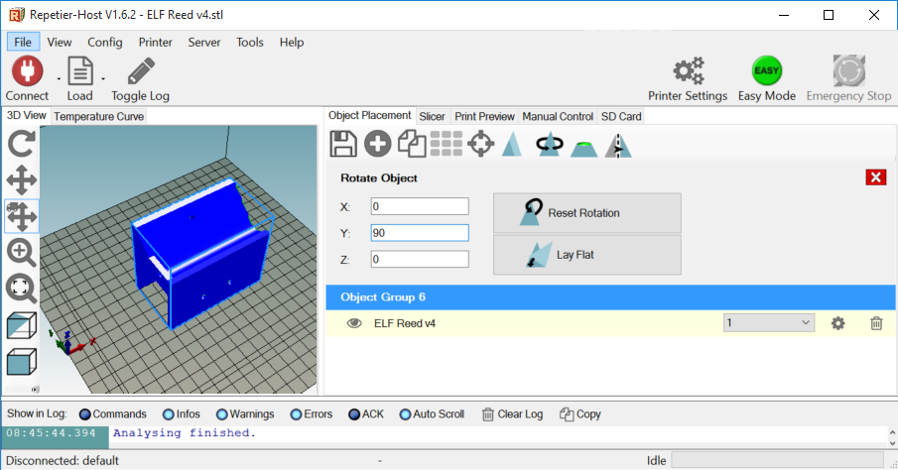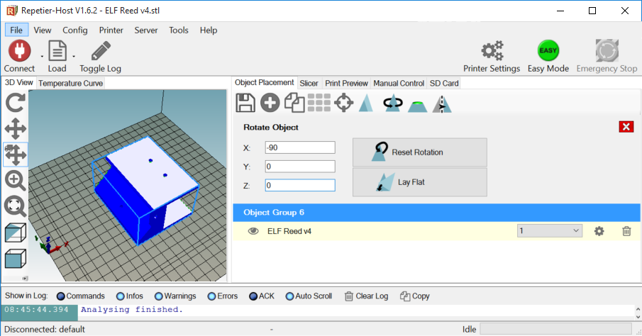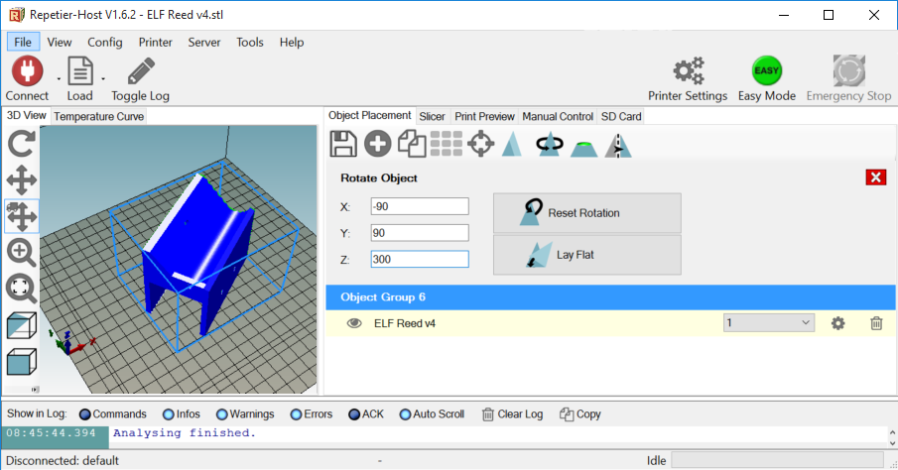

## Insure that Your Object is Properly Positioned on the Virtual Deck

1. Make sure the print will not have overhangs (see image below). Ask your instructor if you are unsure about this!

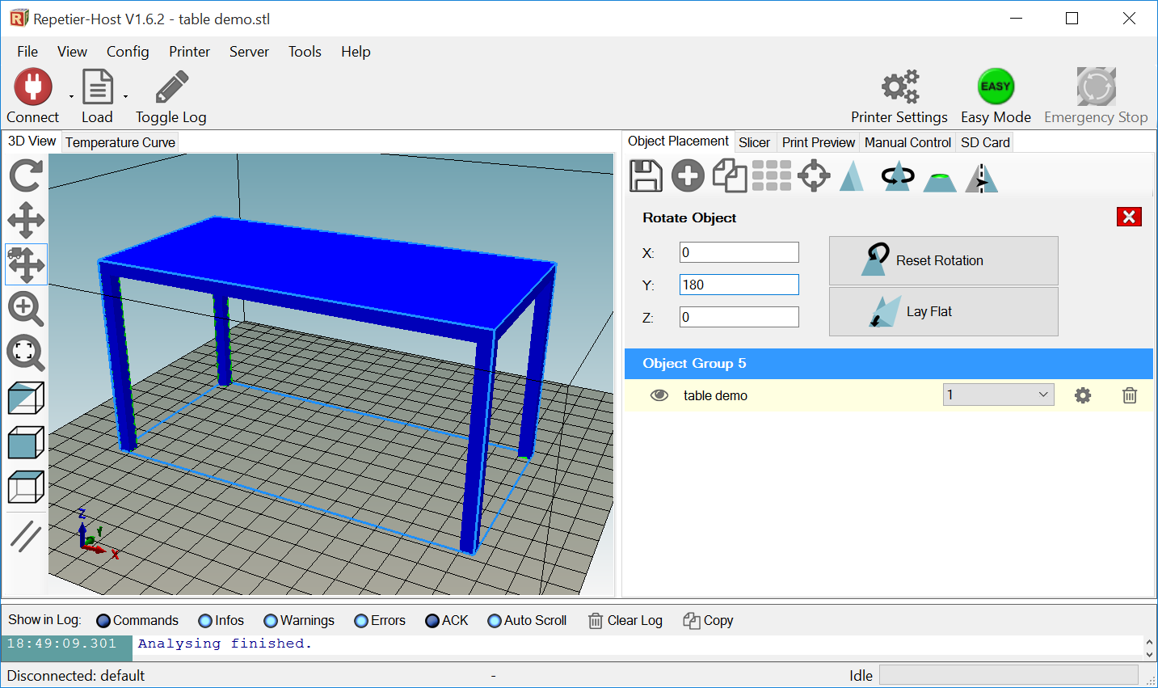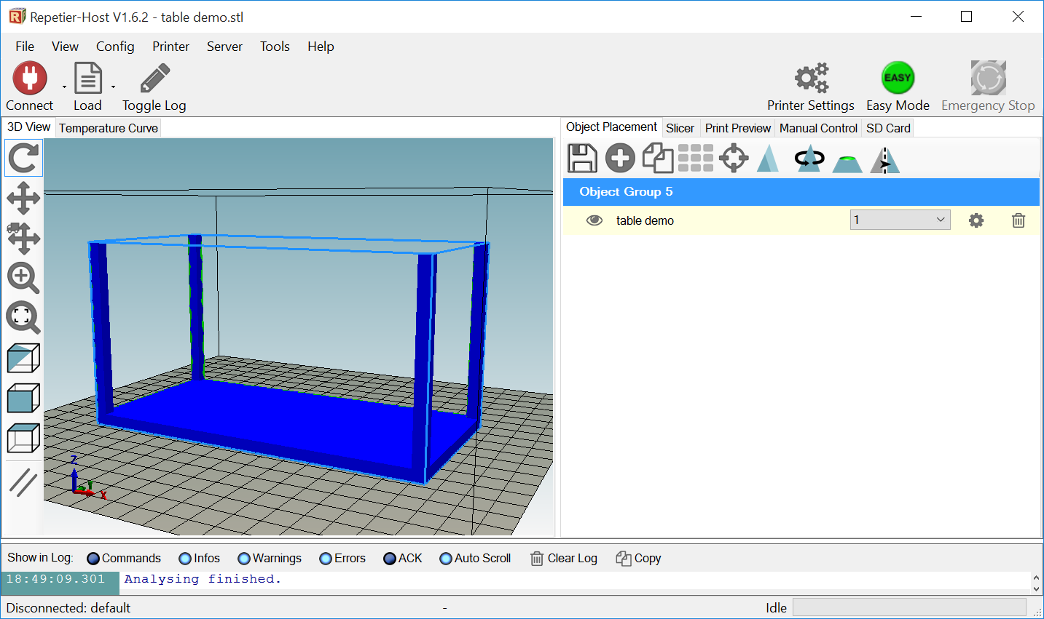

1. Check that the object is **flat on the virtual deck** by pressing the **Cross Section button** and move the **Position Slider** to the far left. The **complete first layer** of your object **must** be 100% visible on the deck, like so:

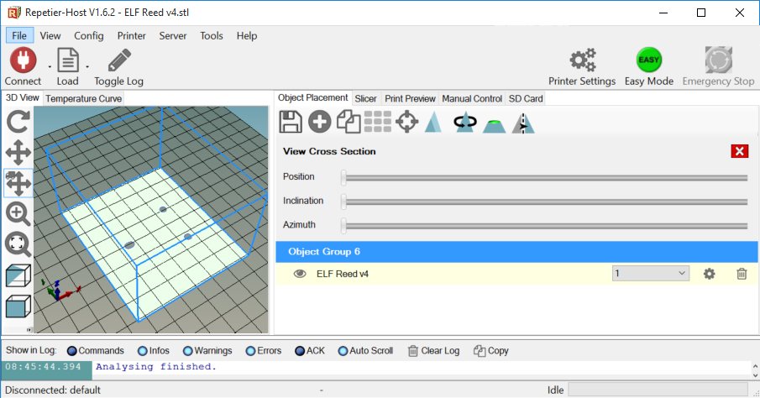

## Slice the STL File into the Repetier Host Software

1. Once your object is correctly positioned on the deck and, more importantly, it is **lying flat** on the deck, you are ready to **slice it**! The STL objects must be ***sliced*** before printing. To do that, open the **Slicer tab** (shown below).

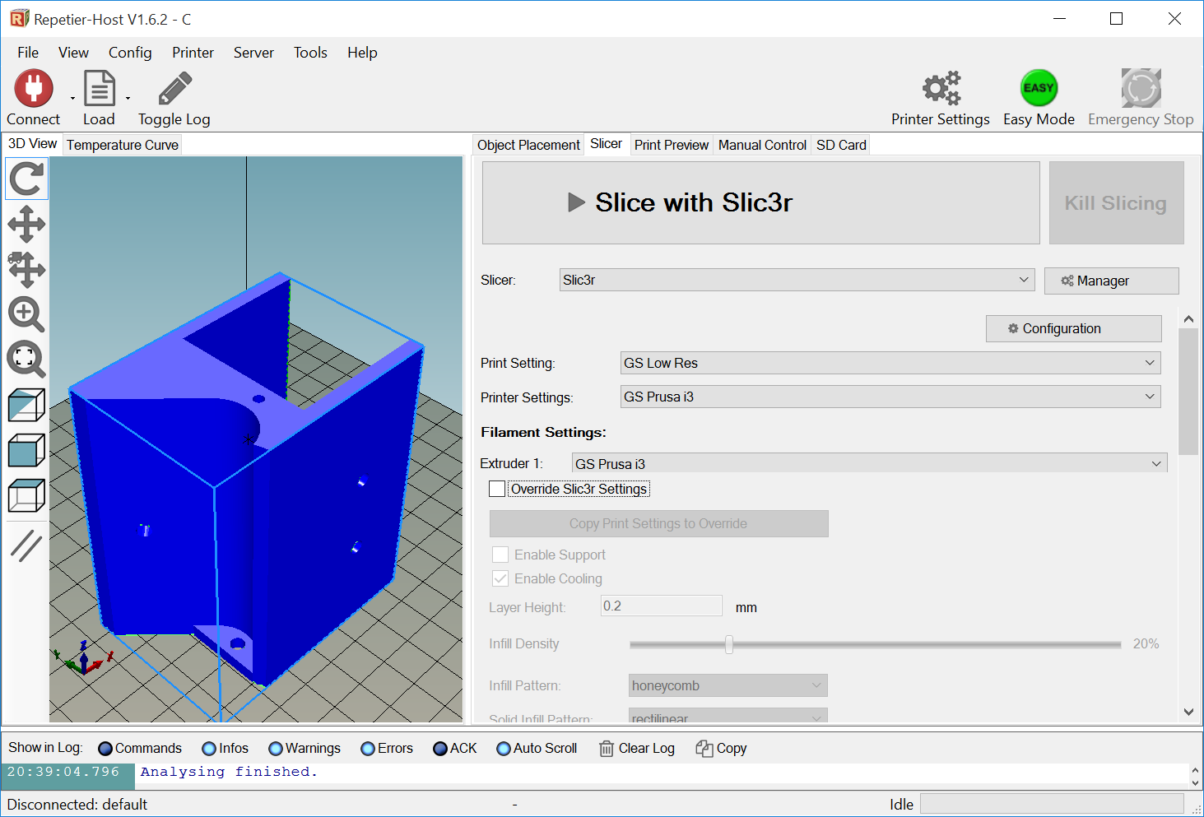

1. Make sure that your *slicer engine* is **Slic3r**! Select “Slic3r” as your slicer, and you should see a big button with the label “Slice with Slic3r”, as shown above.
   * If you do not see the Slic3r option, then you will need to download it from <http://slic3r.org/download>. Choose the one for your operating system.
     1. When it downloads, open it or run it to install the drivers.
     2. Then, return to Repetier and press the **Manager button**:



* + 1. In the window that opens, browse to select the folder that contains the Slic3r file that you just downloaded.
    2. Press the **Apply button**.

1. Once Slic3r is selected, make sure that you have the correct **Print Settings**, **Printer Settings**, and **Extruder 1 Filament Settings**. To do so, press the **Configure button**, which will open a new window after several seconds:



1. Windows users will see the **Configuration Window** below. Mac users will need to first select **Settings** from the menu bar.

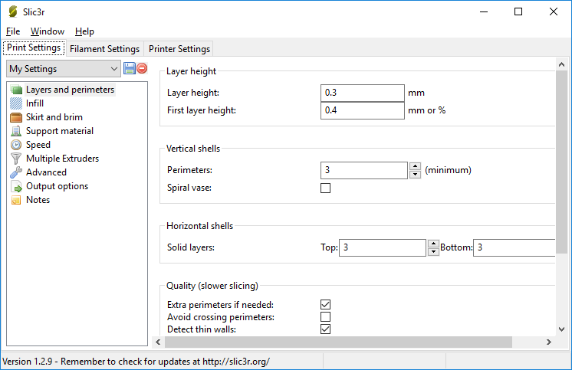

1. Under the **Print Settings tab**, make sure that the following settings match the data below:
   * **Layers and permissions**
     1. Layer height = 0.30 mm
     2. First layer height = 0.35 mm
     3. Perimeters = 3
     4. Solid Layers = Top: 3, Bottom: 3
     5. Quality: All four check boxes should be checked!
   * **Infill**
     1. Fill density = 10%
     2. Fill pattern = Honeycomb
   * **Skirt and brim**
     1. Loops = 3
     2. Distance from object = 5 mm
   * **Support material**
     1. Make sure that the “Generate support material” checkbox is **not** checked!

Save these important settings by clicking on the **Save button:**

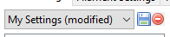

In the window that opens, save the settings with the name, “*GS Print 10pct*”, as shown below:

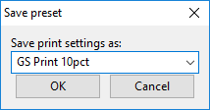

1. Under the **Filament Settings tab**, make sure that the following settings match the data below:
   * **Filament**
     1. Diameter = 1.75 mm
     2. Extruder Temperature = First layer: 205, Other layers: 200
     3. Bed Temperature = First layer: 65, Other layers: 60

Save these important settings by clicking on the **Save button**, and save it as, “*GS Filament*”, as shown below:

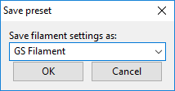

1. Under the **Printer Settings tab**, make sure that the following settings match the data below:
   * **Custom G-code**
     1. 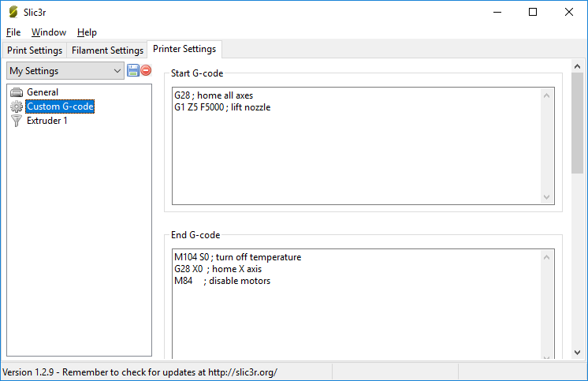Start G-code =
     2. End G-code =



* + **Extruder 1**
    1. Nozzle diameter = 0.40 mm

Save these important settings by clicking on the **Save button**, and save it as, “*GS Printer*”, as shown below:

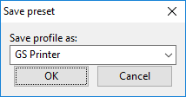

1. Close the see the **Configuration Window** and change the **Print Settings**, **Printer Settings**, and **Filament Settings** to the personalized settings that you just saved, as shown below:

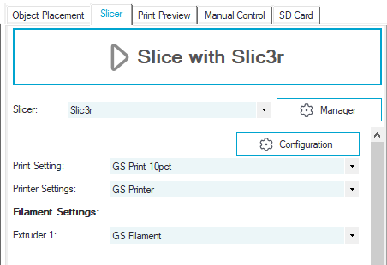

1. These configuration settings are further explained in *Appendix 2: Repetier Host Settings* at the end of this document.
2. Here are some **shortcut keystrokes**:
   * **M**. Rotates the object 180° around the z-axis.
   * **C**. Shows a cross section of your object.
   * **R**. Opens the Rotate Object menu.
   * **T**. Opens the Position Object menu.
   * **S**. Opens the Scale Object menu.
     1. You should **avoid scaling your object** with the Repetier (and MakerBot) software! Rather, get it right in SketchUp. ***Scaling with the rendering software is a bad idea!***
3. Begin the slicing process by pressing the *huge* **Slice with Slic3r button**:

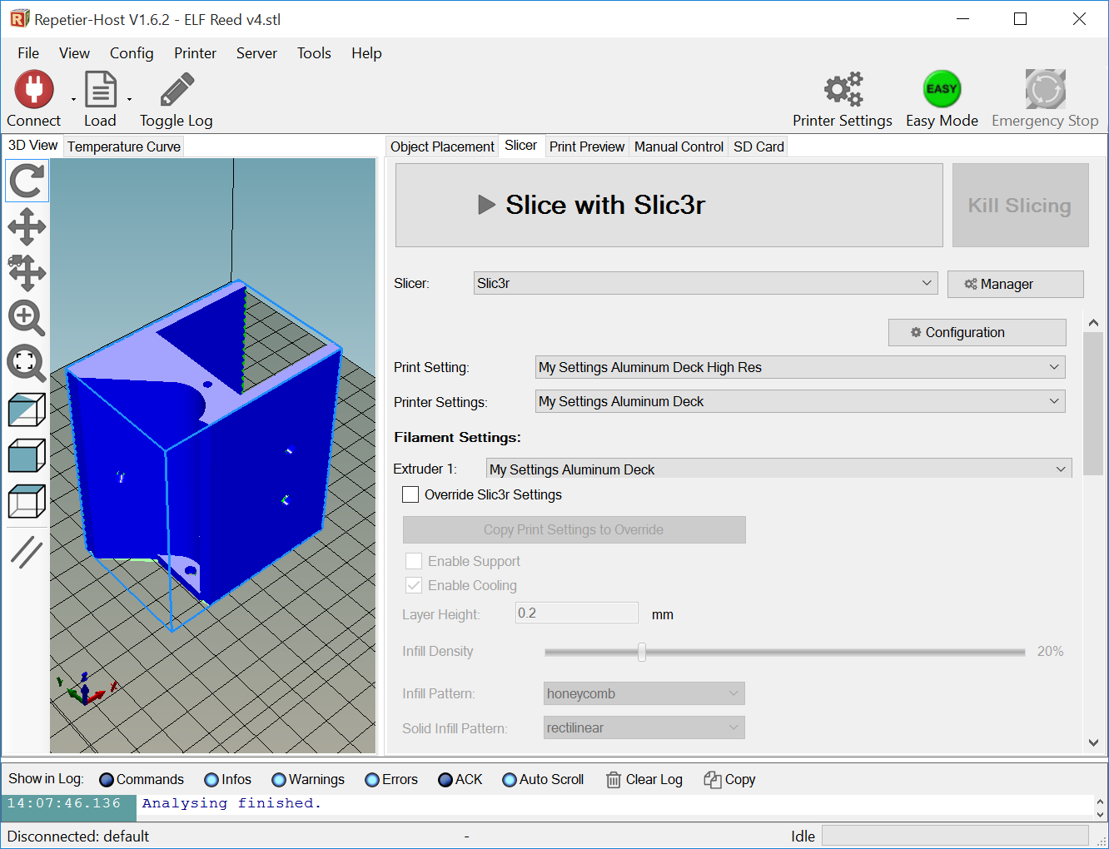

1. After a few seconds, the **Print Preview menu**, shown below, will open. Examine the **Printing Statistics** information and note the amount of time and plastic required to print. If it is an especially long print (like the one shown below), inform your instructor before printing.

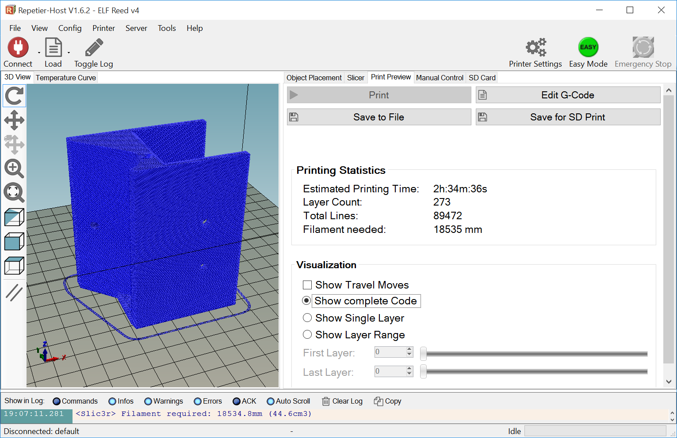

1. Before you can print, you **must verify that the first layer of the print is actually on Layer 0!** To do this, toggle the **Show Single Layer** radio button under the **Visualization** menu. Then, move the **First Layer** slider to Layer 1 or enter “1” in the box, as shown in the image blow. (If your object’s bottom layer does not begin on Layer 1, return to the **Object Placement** menu and reposition the object so that it is sitting flat on the deck!) **Your Layer 1 preview must look like this before proceeding:**

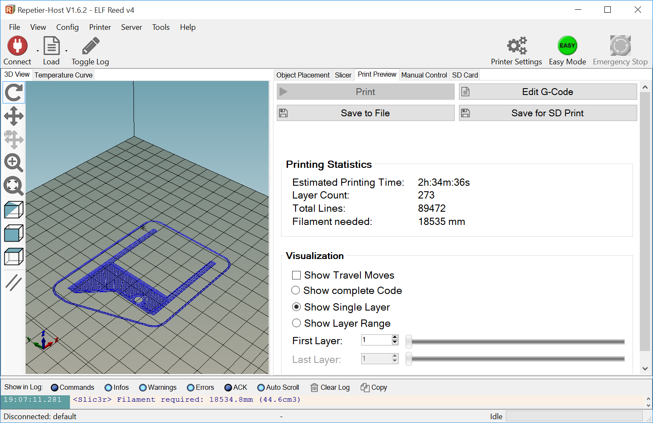

1. 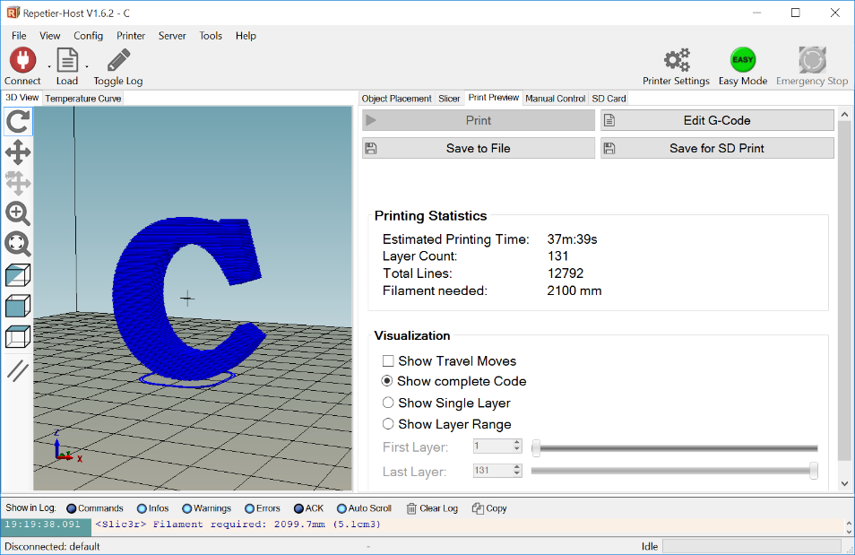Use the **Show Layer Range sliders** to carefully examine each layer of the print. If some part of your print is being printed in mid-air, the **print will fail!** (See images below.) **If this happens, you will need to reposition the piece on the virtual deck or print using supports!**

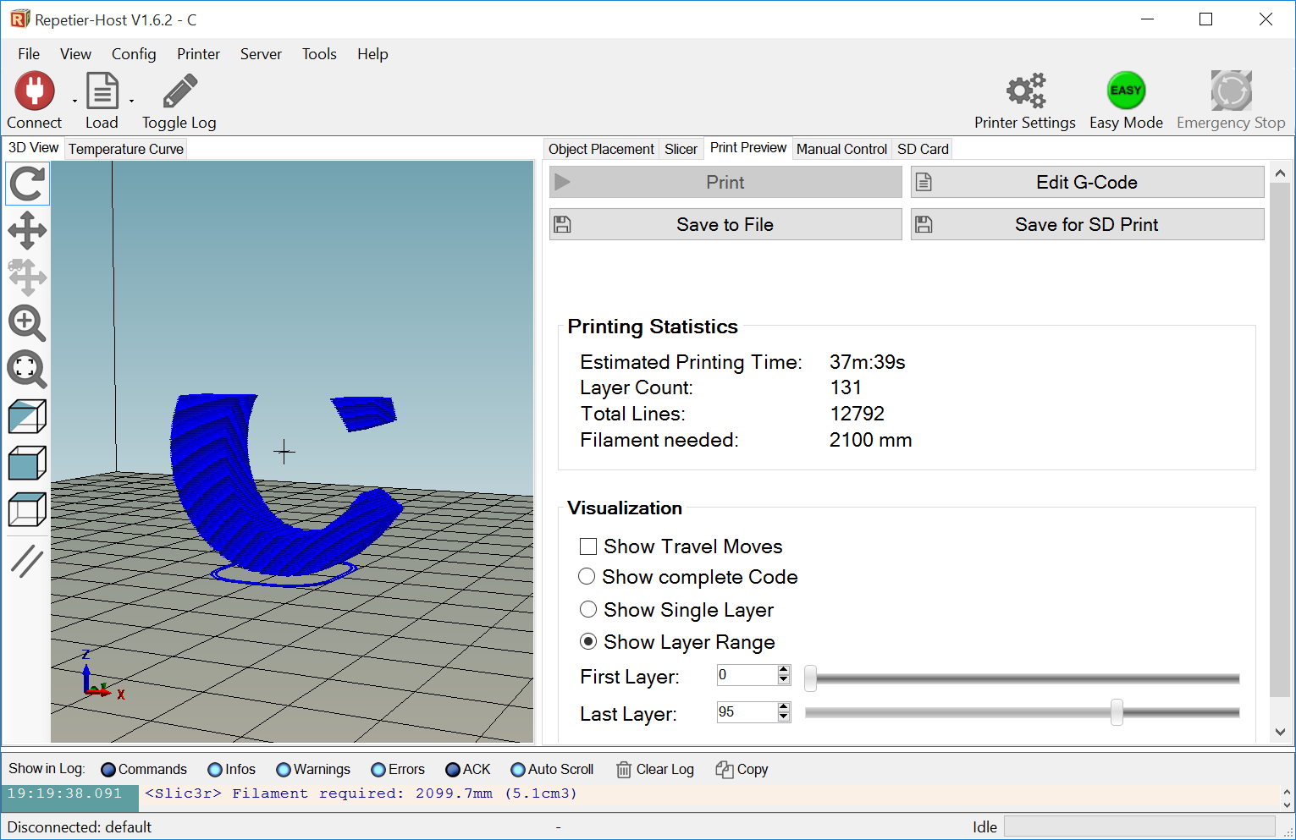

## Save and Export the Sliced Object as G-Code

1. If all the layers look OK, you can output your sliced object as **G-Code**, which can be read by any of the Prusa i3 3D printers in the lab. (The MakerBot Replicator 2 printer **cannot** read G-Code!) From the **Print Preview** menu screen, there are two recommended ways to output your code for printing:
   * **Print** directly to the 3D printer (if you are connected, that is).
   * **Save** your G-Code to be an SD Card via the **Save for SD Print button**. This will be your typical **default** choice!

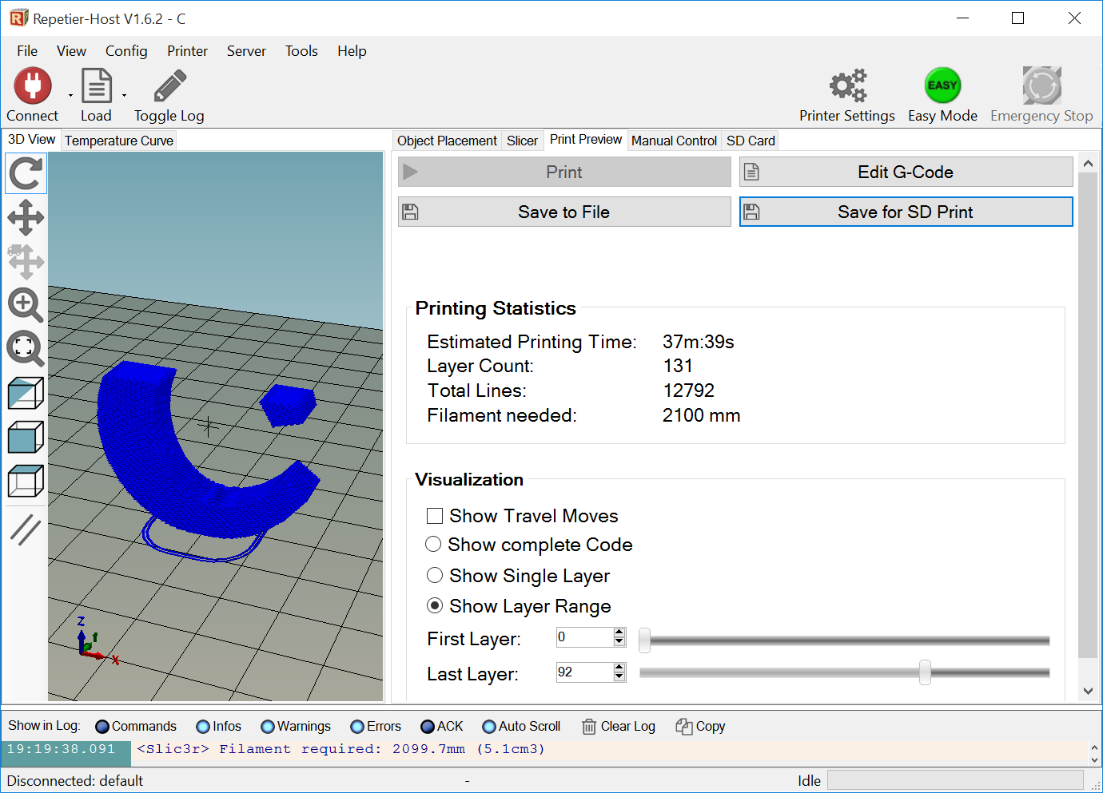

1. Most often you will choose the **Save for SD Print** option. In the window that opens, check the boxes for “Include ‘Start’ and ‘End’ Code” and “Include Job Finished Commands”, as shown in the image below. The press the **Save button**.

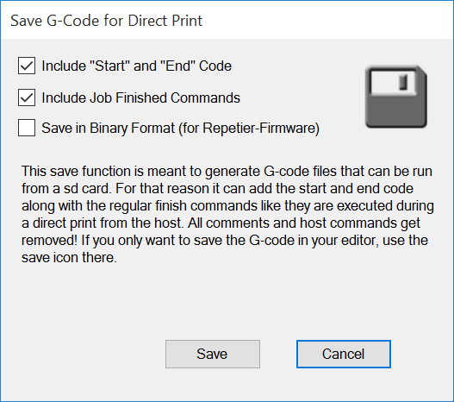

1. Save the exported G-Code **(*.gco)** file with these guidelines:
   * 1. (Short) name of the print.
     2. Version number of the print.
     3. Your initials.
     4. Like so: **“Table v2 CDO**”.
     5. Save the file in your 3D printer or SketchUp folder.
2. The .GCO file can now be transferred to an SD card and taken to the printer to be printed. Move your exported *.gco file to one of the **Micro SD Cards**, which are stored either in the SD Adapter or the USB sticks:

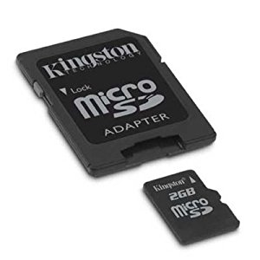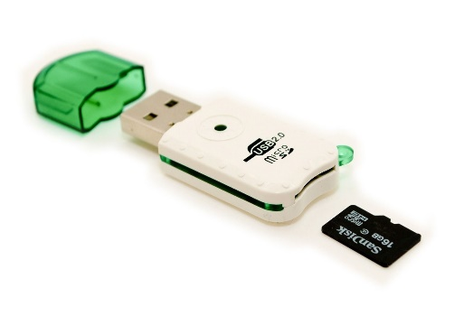

1. You are ready to Insert the card into one of the Prusa i3 printers and print your object! Skip to the **Prusa i3 Printer Instructions** section.

# Prusa i3 Printer Instructions

1. Some general rules for the printer:
   * Never use tools (knives, razorblades, etc.) to remove a piece from the deck of the printer! Ever. **You will receive a failing Lab Skills grade if you do.** I’m serious! Get your teacher to remove it if tools are required. Seriously.
   * A ***little*** hair spray makes the plastic stick nicely to the printer deck.
   * Do not attempt to adjust the level of the deck – even just a little bit! If you want to practice leveling a deck, buy your own printer and practice with it!
   * Do not remove another student’s piece from the deck. Ask its owner or your teacher to remove it.
   * Do not load or unload the filament without teacher supervision.
   * Make sure the PLA filament is kept in air-tight zip-lock bags that have desiccant in them to absorb water from the air.
   * Do not remove the SD card from the controller board while the printer is in operation!
   * Every micro SD card should either be in the 3D printer or in its USB adapter. We should never see a micro SD card sitting out the desk, for example!

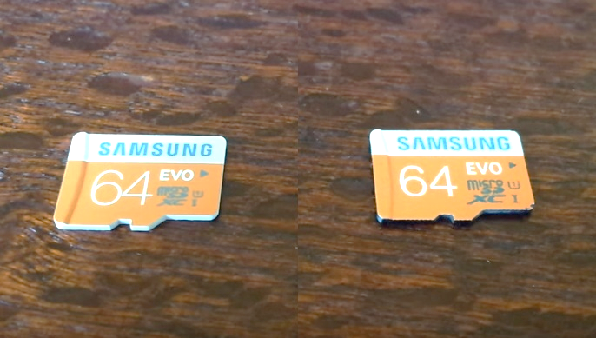

1. Insert the micro SD card into the card reader at the top of the printer’s controller board like so:
2. Using the buttons and LCD screen at the top of the printer, load the zzz
3. Once the printing begins, sit and **carefully watch the first two layers of your print**. If they print well (that is, adhere to the deck), you can go back to programming or building your robot, or head to lunch. Do **not** sit and watch the entire print – unless the job will take less than 3 minutes. **If the print job looks questionable or is not adhering to the deck, ask your instructor for help.**

# MakerBot Software Instructions

1. Check the bottom left corner of the software’s window that the device is the Replicator 2:

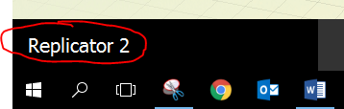

If not, then select **Devices >> Select Type of Device >> Replicator 2** from the menu bar.

1. Select **Prepare** on the top ribbon bar:

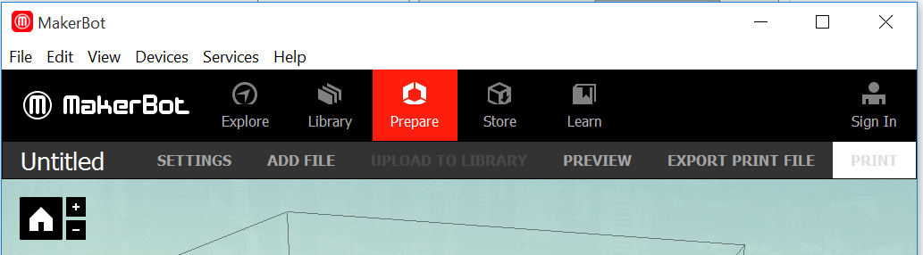

1. Place your *.STL object (which was exported from SketchUp) on the virtual deck of the MakerBot software, either by dragging it to the deck, selecting **File >> Open**, or selecting **ADD FILE** from the ribbon bar:



1. Select the object and use the **Move** and **Rotate** buttons to place the object **flat** and in the **center** of the deck:

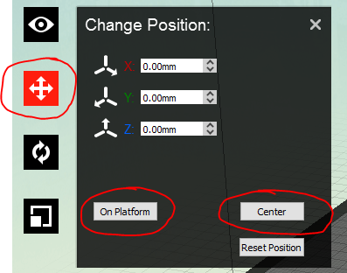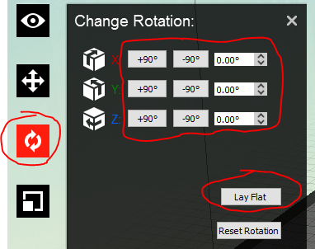

1. In the **View** option, you can move **orbit** around by using a mouse click, **zoom** in and out using the mouse scroll wheel, and **pan** around by pressing SHIFT+mouse click.
2. Make sure the print will not have overhangs (see image below). Ask your instructor if you are unsure about this!

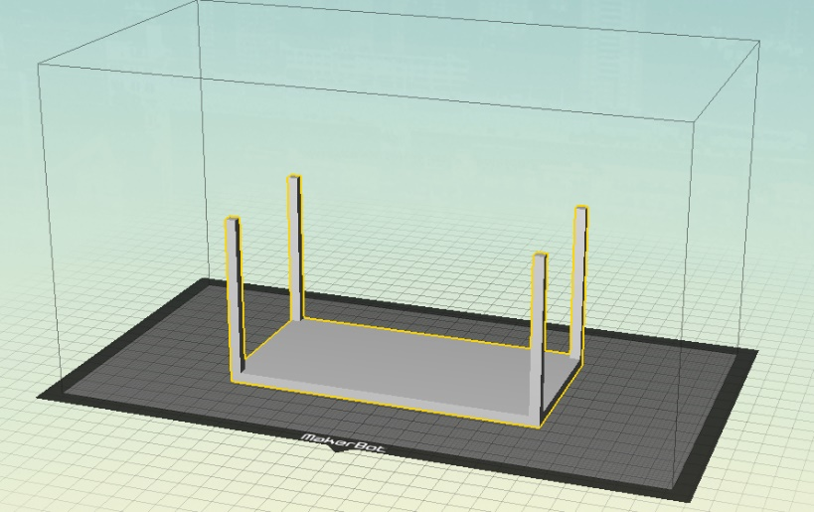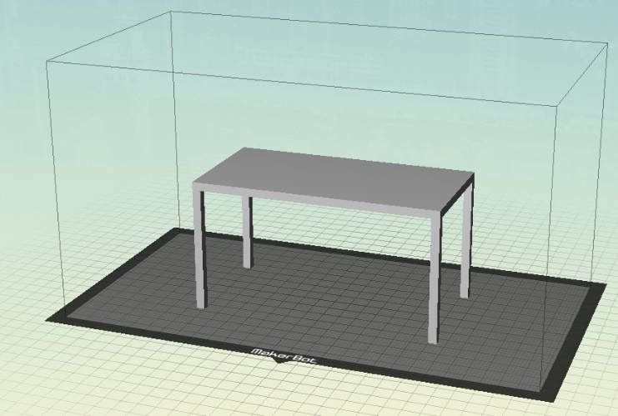

1. Click on **Settings**:
   1. Choose **Low preset**.
      1. For preset settings, see *Appendix A: MakerBot Settings*at the end of this document.
   2. Press **OK**



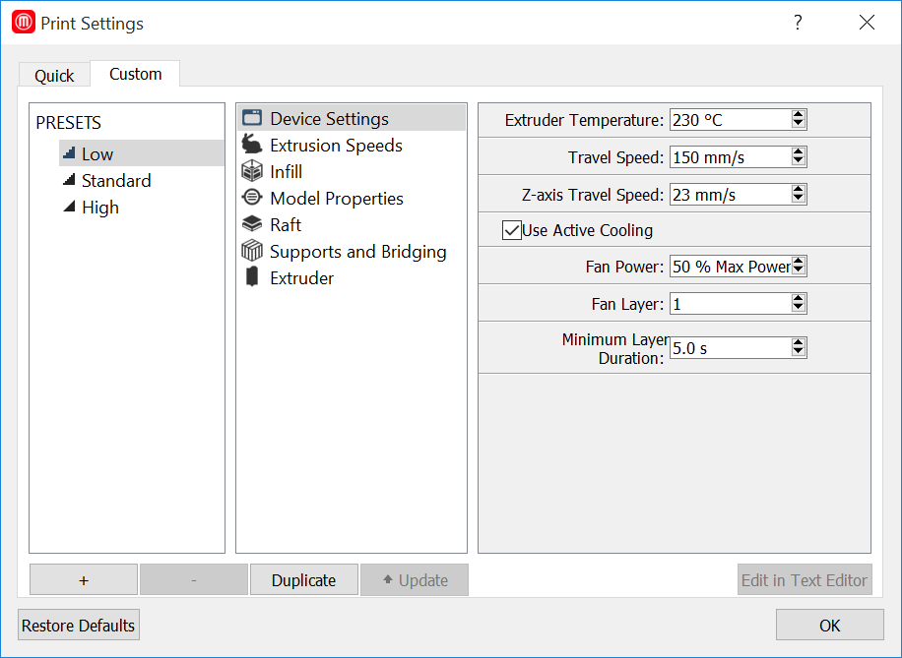

1. Click on **Preview**:
   1. **You must do this with every print!!!**



* 1. Note the amount of time required to print. If it is an especially long print (like the one shown below), inform your instructor.

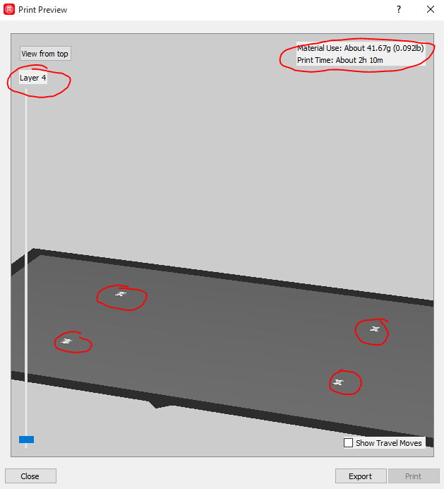

* 1. Move the slider to the bottom layer. For some unknown reason, the **first layer of the print will appear on Layer 4**. (If the print does not begin on Layer 4, close the window and reposition the object so that it is sitting flat on the deck!) Your preview should look like this:

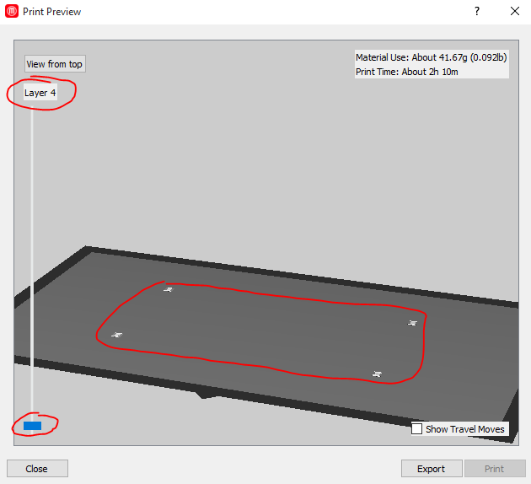

* 1. Use the slider to carefully examine each layer of the print. If some part of your print is being printed in mid-air, the **print will fail!** (See images below.) **If this happens, you will need to reposition the piece on the virtual deck or print using supports!**

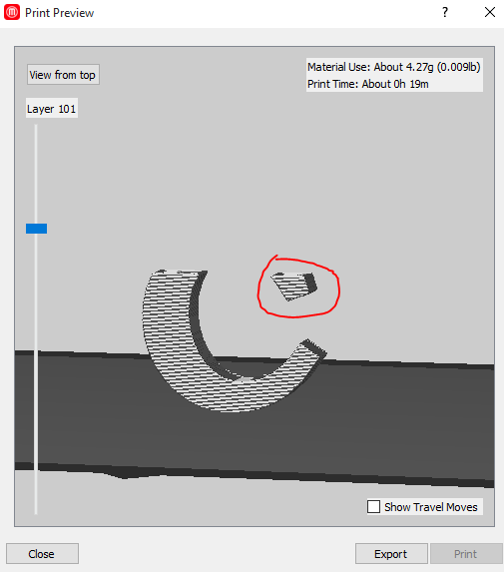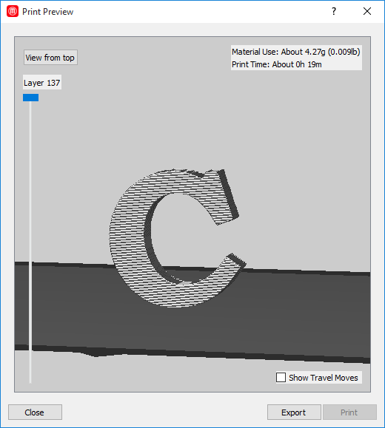

* 1. If all the layers look OK, press the **Export button**.



* 1. Save the exported **(*.X3G)** file with these guidelines:
     1. (Short) name of the print.
     2. Version number of the print.
     3. Your initials.
     4. Like so: **“Table v2 CDO**”.
     5. Save the file in your 3D printer or SketchUp folder.

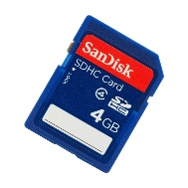

1. Move your exported *.X3G file to one of the **SD Cards**:
2. You are ready to Insert the card into the MakerBot Replicator 2 printer and print your object. Skip to the **MakerBot Replicator 2 Instructions** section.

# MakerBot Replicator 2 Instructions

1. (We really don’t use the MakerBot. The Art Department needs to come and get it.)

# Appendix A: SketchUp Hints

1. Have an idea about what you want to print. This usually comes after you see a need for a 3D-printed thing as you go about your daily life. Keep your eyes open!
2. Draw (on paper) what you want to print.
   1. Know the dimensions of your object **before** you even open SketchUp!
   2. If you don’t know the exact dimensions *a priori*, use a real-world object that is about the same size as the thing you want to make, and use those rough dimensions for starters.
3. SketchUp tutorials on YouTube:
   1. Chris’s tutorials playlist: <https://www.youtube.com/playlist?list=PLGlU0977_w8BSaQ1Bpw14jvdBHaIa3yKD>
   2. Miscellaneous tutorials playlist on Chris’s channel: <https://www.youtube.com/playlist?list=PLGlU0977_w8DGseJgqBlZZQNEeKXVZ4PA>
   3. 2hr 40min nice tutorial: <https://youtu.be/_2RRkGG7y7k>
4. When drawing objects in SketchUp Make, keep these things in mind:
   1. Know your measurements first, then design the objects!
   2. **Orbit** and **Pan** often!
   3. Look for faces with different colors, which indicate an inside-out face. Try right-click then reverse face.
   4. **Save** often
   5. To make a **Circle** (or any polygon):
      1. Make circle.
      2. Before doing anything else, type size of **radius**
      3. Type “100s” to make a 100-sided circle. (Or “5s” for a pentagon, etc.)
   6. Use the **Dimension** tool to show dimensions on edges and circumferences of objects!
   7. Say you want to have multiple shapes pushed/pulled the same amount. Here’s how:
      1. Create your shapes
      2. Pull one object the correct amount
      3. Double-click on the other objects and they will be pulled the same amount.
      4. You can also make use of **Components** (see below).
   8. When using the **Move** tool, move along only one axis at a time:
      1. To constrain moves along a particular axis: highlight object >> click on object >> Grab **Move** tool >> press up/down arrow to move along z-axis, right arrow for red axis, left arrow for green axis.
      2. To move object to a particular plane: triple-click object to select all >> select **Move** >> click on desired plane of object >> lock in axis (up/left/right arrow buttons) >> then click on desired plane you wish to move to.
   9. To change the color of a line in SketchUp – for instance to differentiate the colors of the line and a silhouette when making an ornament or decal for your toolbox – do this:
      1. Draw your line. The default color of the line is black, which is not visible on the black silhouette background:

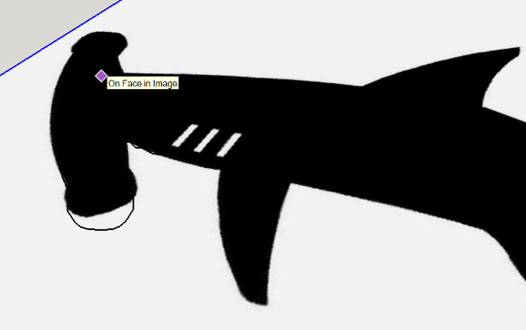

* + 1. Right-click anywhere on the model and select **Entity Info**:

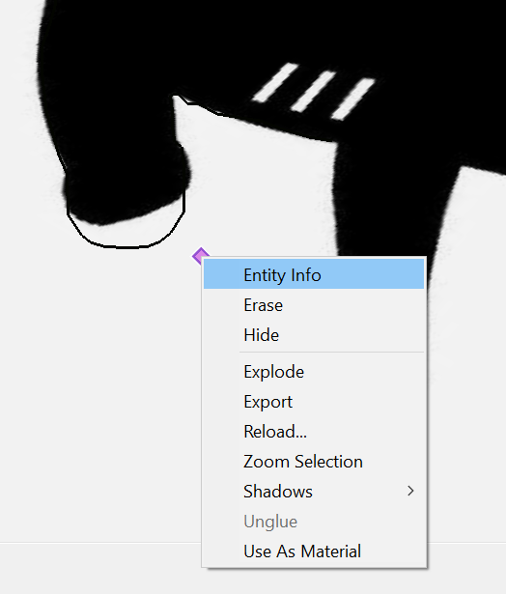

* + 1. The **Default Tray** window will pop up on the right. Locate the **Styles tray**:

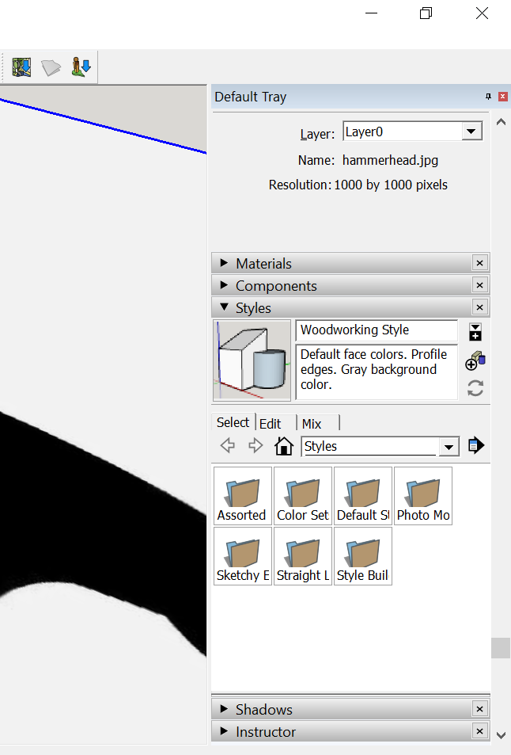

* + 1. Press the **Edit tab** and place a check in the **Edges Checkbox**:

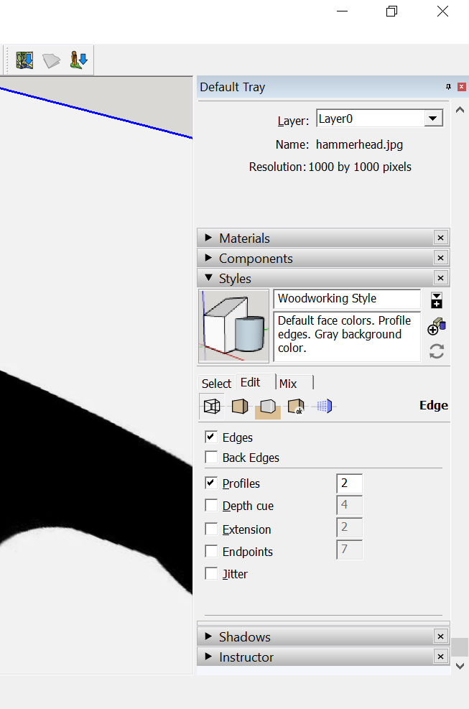

* + 1. From this window, you can change the color of the lines (edges). The problem is, *you cannot see the* ***Color Box*** *unless you enlarge the* ***Styles*** *window by* ***stretching the bottom edge****:*

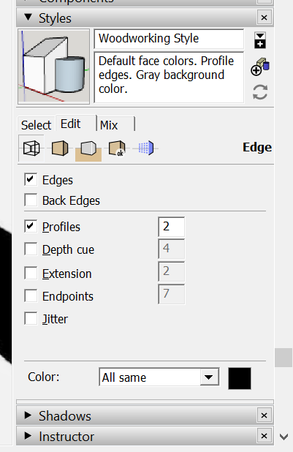

Grab this bottom edge and stretch the Styles Tray!

* + 1. Click on the **Color Box**, and select **both** your **color** and **shade** (see image below). Press the **OK button**.

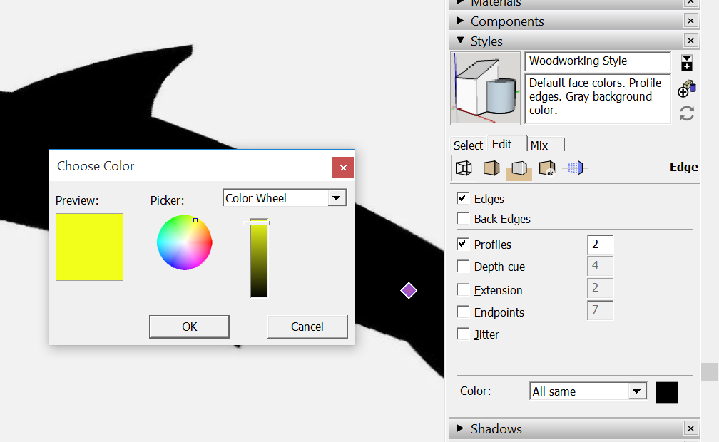

* + 1. 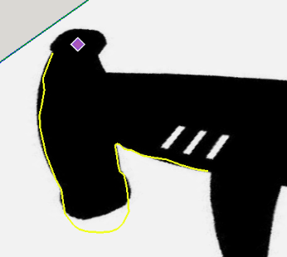The color of your lines have now been altered:
  1. To place one object on another:
     1. View >> Face Style >> X-Ray
     2. Select Object
     3. Select **Move** tool
     4. Click on point on object you’d like to place on the other object
     5. Click on face/edge/point on 2nd object you’d like to move
  2. To make a **group**:
     1. Select object >> Right-click >> Make Group
     2. A blue box will form around solid object.
     3. When joining objects, best idea is to make them individual groups.
  3. To **rotate** a grouped object:
     + 1. Group the object (see above).
       2. Select **Move** tool and click/drag on the red crosses:



* 1. To make a **component**:
     1. Select object >> Right-click >> Make Component
     2. Name component.
     3. A blue box will form around solid object.
     4. Now, when you copy and paste (or Move/Copy) the component and change *any of the components*, they will all change.
     5. To change the component, Right-Click on the component and select **Edit Component**. Any changes made will be made to all components – **wicked cool!**
     6. Click off the object to close the edit.
  2. Use **Section Plane** and/or **X-Ray View** tool to see inside your objects. Very useful when editing!
     1. Can move and rotate the Section Plane like any other plane.
     2. Erase it when done.
     3. See <http://www.youtube.com/watch?v=ZiMA1IAn8HU&safe=active> for nice tutorial.



* 1. Solid tools are *awesome*! (However, these tools are now unavailable for the free-version of SketchUp.) Add them to your toolbar: **View >> Toolbars >> Solid Tools**:
     1. 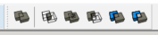Solid tools:
     2. First, **group** each object (see above), **move** the pieces into/onto each other, then highlight the combined piece:

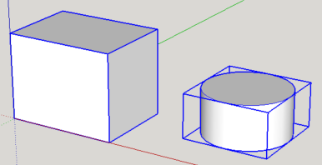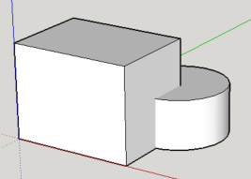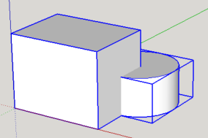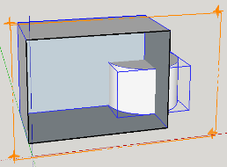

* + 1. **Outer shell:**

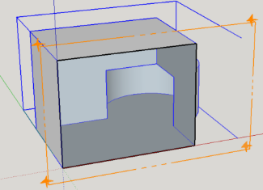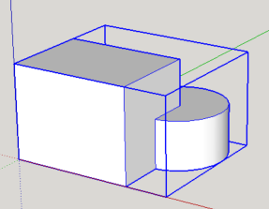

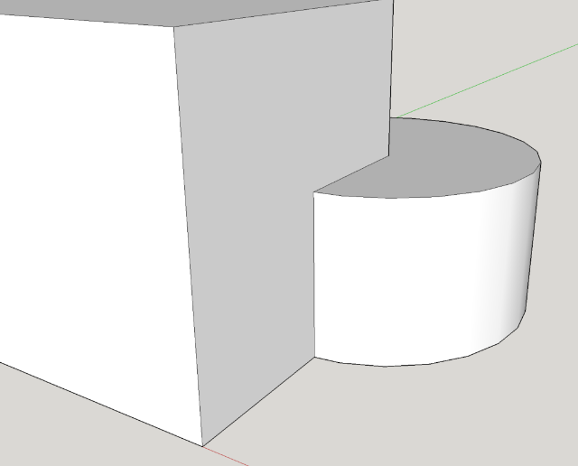

* + 1. **Intersect:**

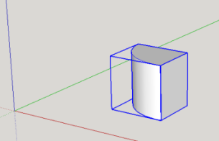

* + 1. **Union:**





* + 1. **Subtract:**

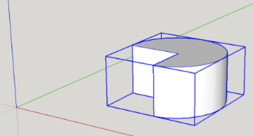

* + 1. **Trim:**

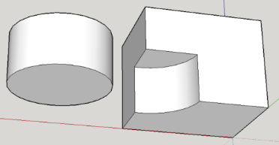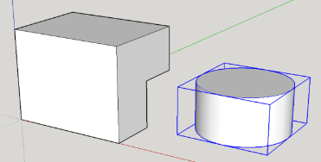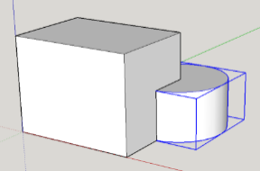

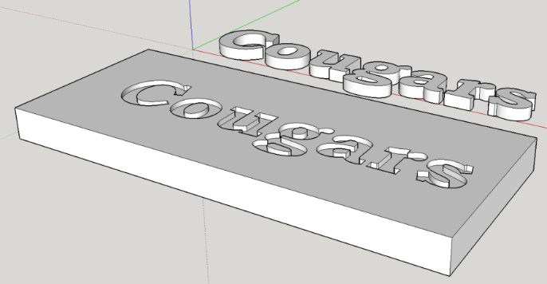

* + 1. **Split:**

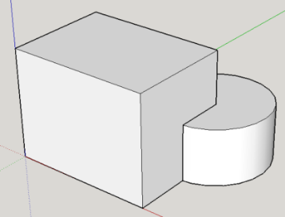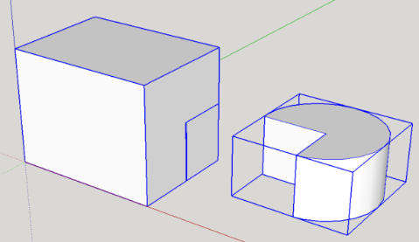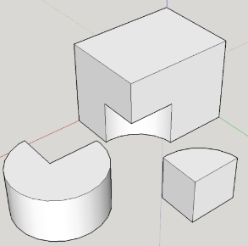

1. To Export your SketchUp (*.SKP) file as a **stereolithography (*.STL)** file, you will need to install the SketchUp STL Extension.
   1. If this is your **first time** to install the STL extension, do the following:
      1. Open SketchUp
      2. Select **Window >> Extension Warehouse**
      3. In the window that opens, search for “STL”, like so:



* + 1. Select the **SketchUp STL Extension:**



* + 1. In the window that opens, press the **Download button**:



* + 1. After logging in, press the **Install button**:



* + 1. Once the extension is installed, you may want to locate the Ruby (rbz) file so that others (i.e., students) can download it without having to log in. (See Step b. immediately below!) The location all the SketchUp extensions are found here:
       1. Windows:

C:\Users\YOUR USERNAME\AppData\Roaming\SketchUp\SketchUp 2017\SketchUp\Plugins

* + - 1. Mac OSX: Version 2013 and newer: Open a new Finder window, press and hold the Option key on your keyboard, the click **Go** in the menu bar **> Library > Application Support > SketchUp # > SketchUp > Plugins**

Mac users need to pay particular attention here, as it is a common misconception that the plugins folder is located with the SketchUp package.

**A note about *.rb files:**

* .rbz is a .rb file that is zipped and the .zip extension is changed to .rbz this allows you to install .rbz files from the preferences panel to install .rb files you need to place those in your plugins folder manually .rbz works in both the Free and Pro version of SketchUp
* If you prefer the .rbz way, you can always right click on an .rb file and send it to a ZIP file then rename the ZIP extension to .rbz and you can use the preferences installing way. Similarly, if you have a ZIP'ed plugin already, just rename the extension.
  1. If you have downloaded the STL extension before, and have access to the STL Ruby file (see above point -- it will look something like “sketchup-stl-2.1.4.rbz”), you can install the STL extension, by doing the following:
     1. For SU 2017 and beyond, select **Window >> Extension Manager** and press the **Install Extensions button** (see below). For older versions, select **Window >> Extension Manager >> Extensions**.



* + 1. Locate the Ruby file and install it.
    2. You may need to restart SketchUp for the extension to appear in the menu. (See below.)

Export your SketchUp (*.SKP) file as a **stereolithography (*.STL)** file, by clicking on **File >> Export STL…**.

* 1. If your drawing has instances of other objects, you may need to highlight only the relevant piece and then check the “Export selected geometry only box (shown with the arrow below).
  2. Use the Model Units and ASCII defaults.



1. You are now ready to prepare the *.STL file for 3D printing using either the **MakerBot Desktop** or **Repetier Host** software.

# Appendix B: Repetier Host Settings

## *Important* Printer Settings:

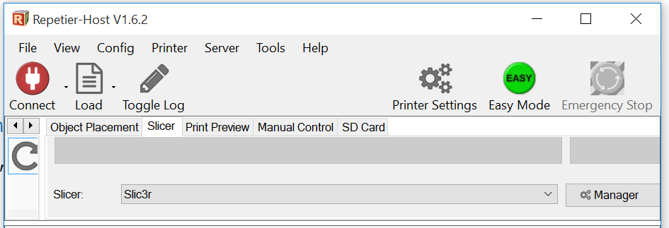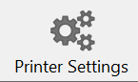

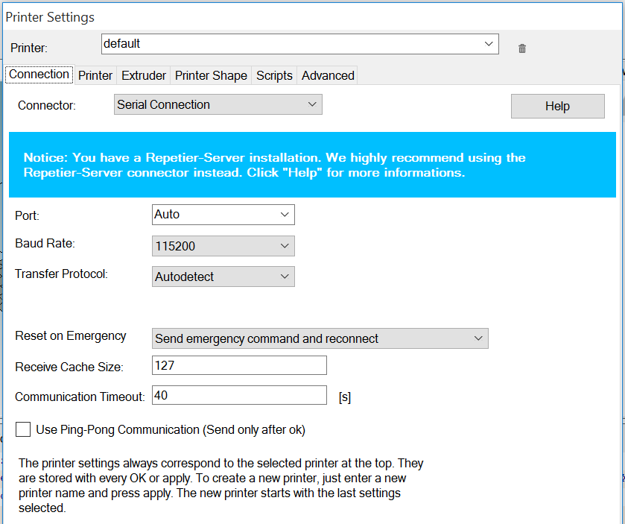

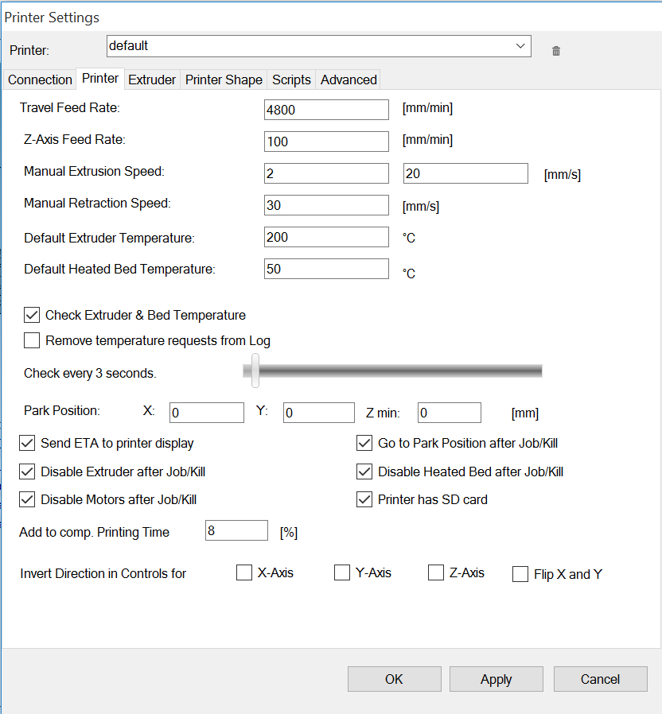

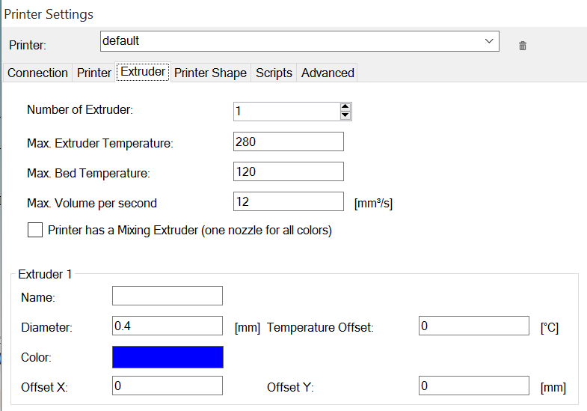

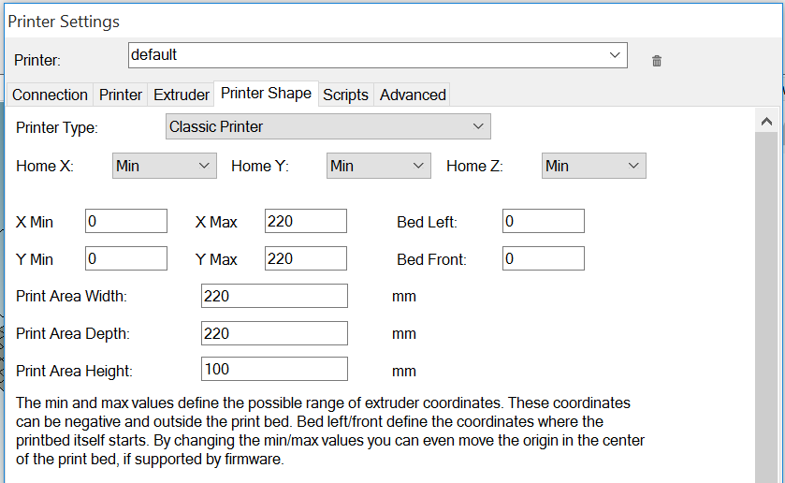

## *Important* Slicer CONFIGURATION Settings:

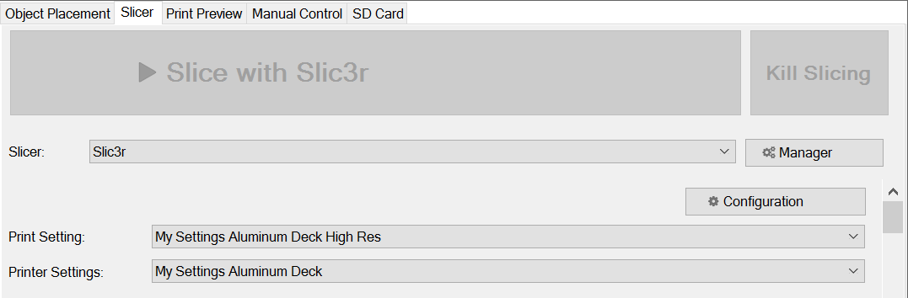

Names will vary. You saved and named your printer and printer settings this up when you set up the Repetier Host software.

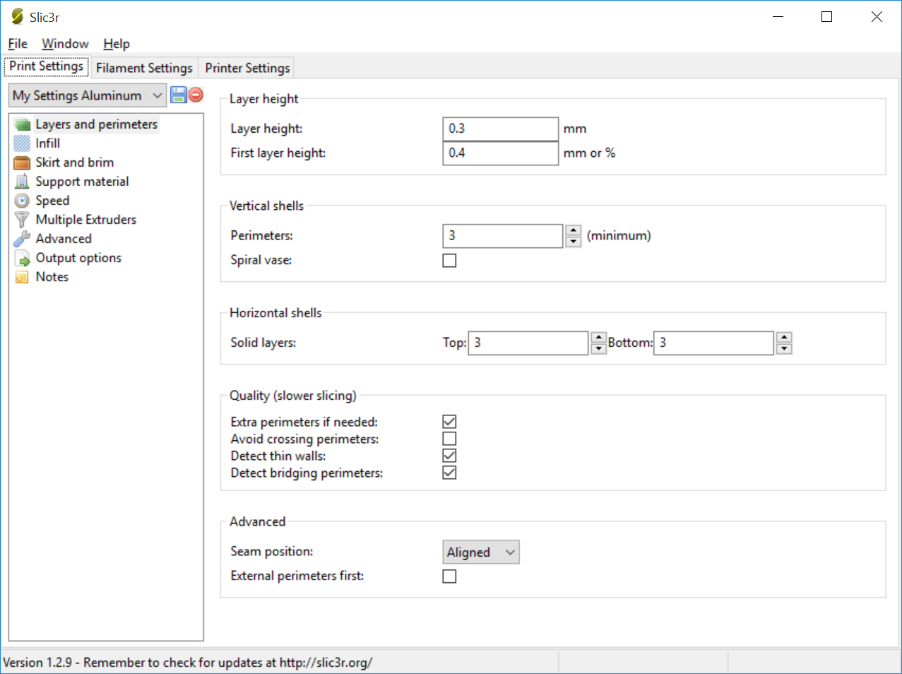

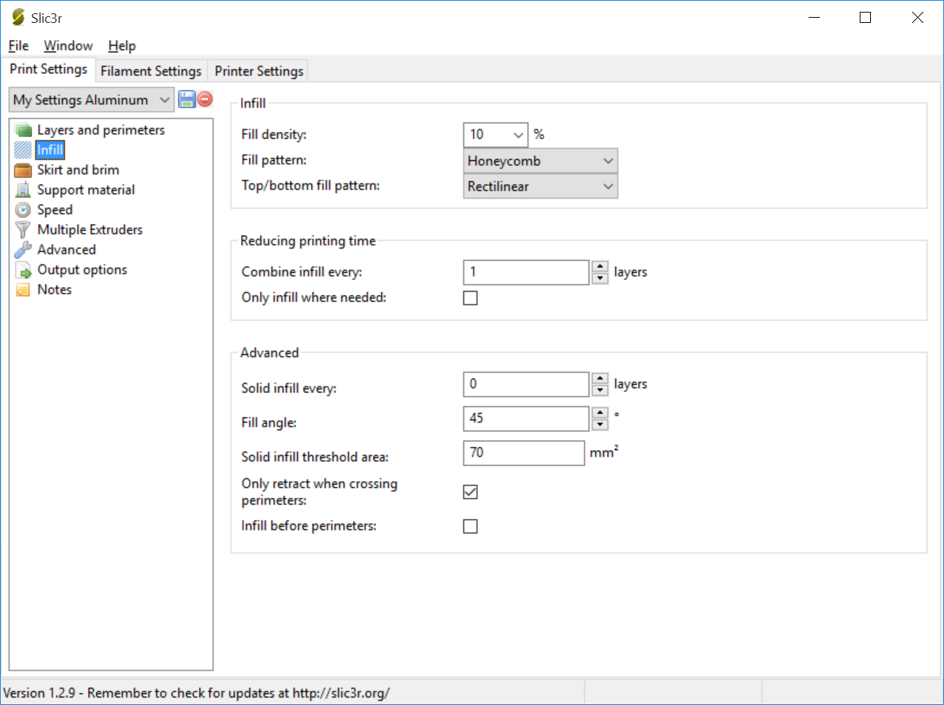

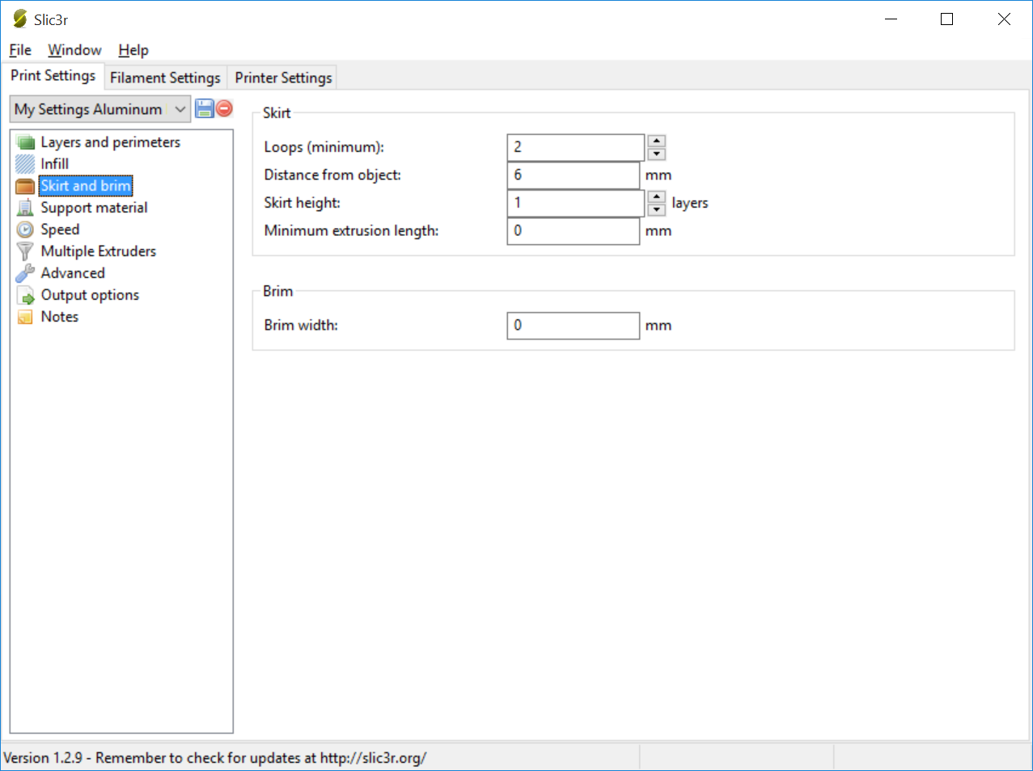

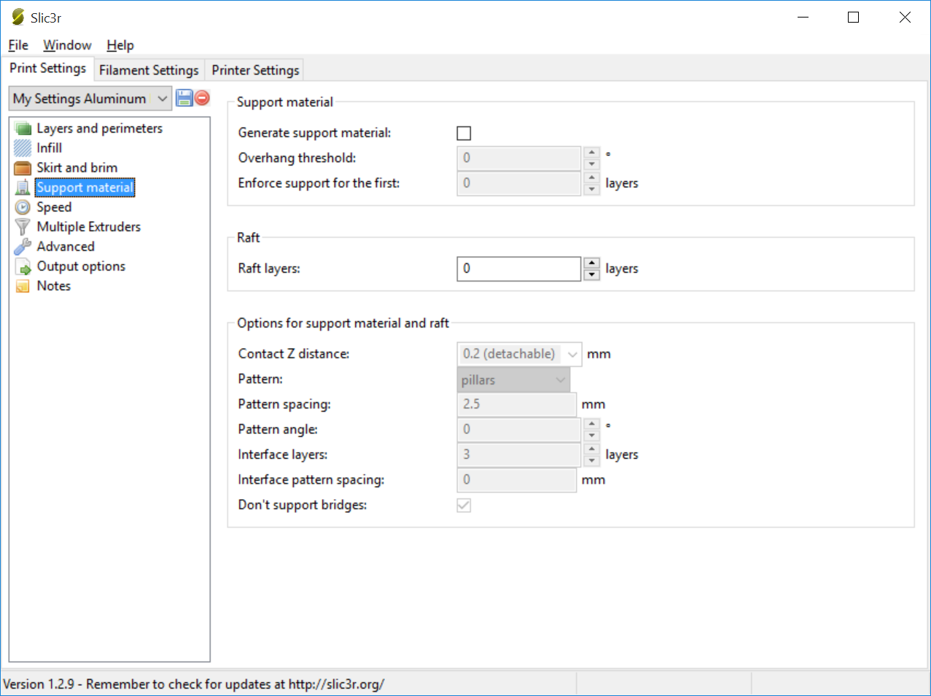

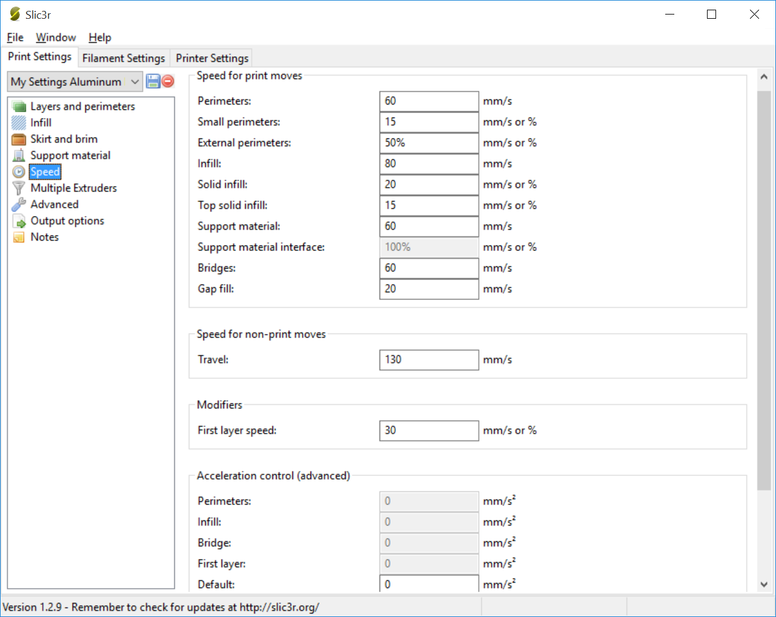

Save these **PRINT** setting (if you didn’t already)

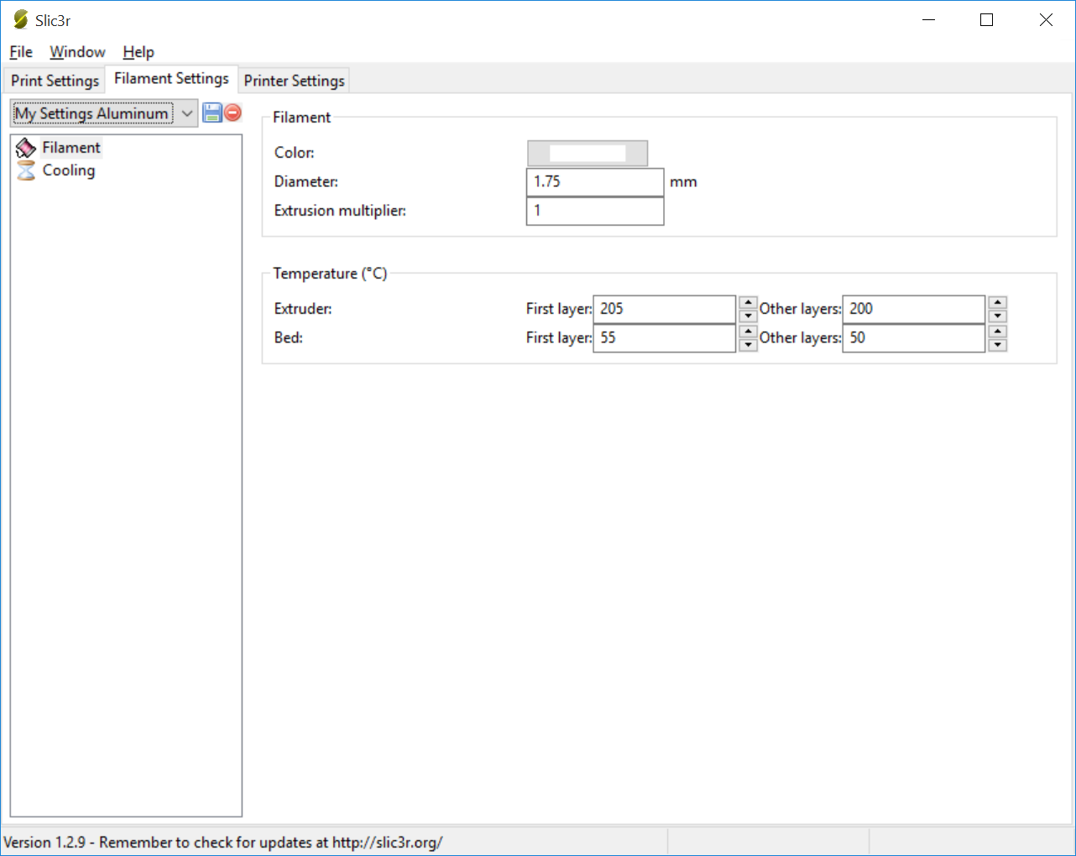

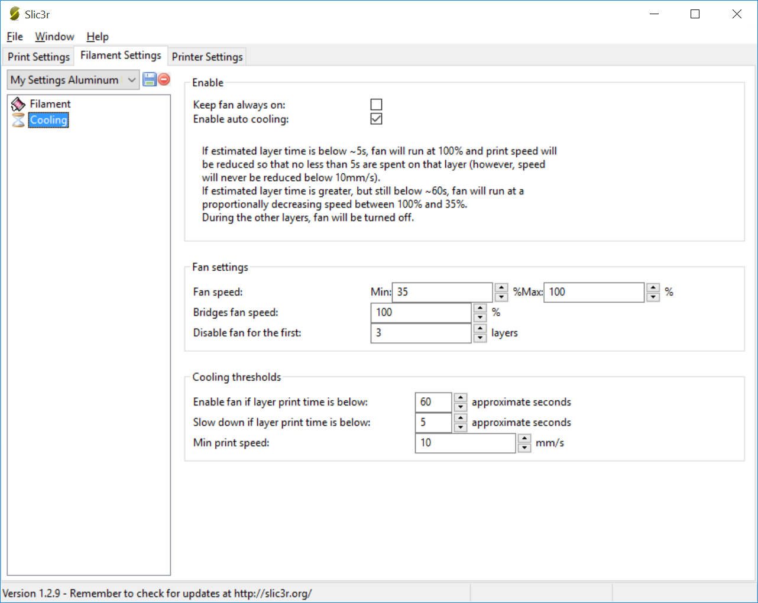

Save these **FILAMENT** setting (if you didn’t already)

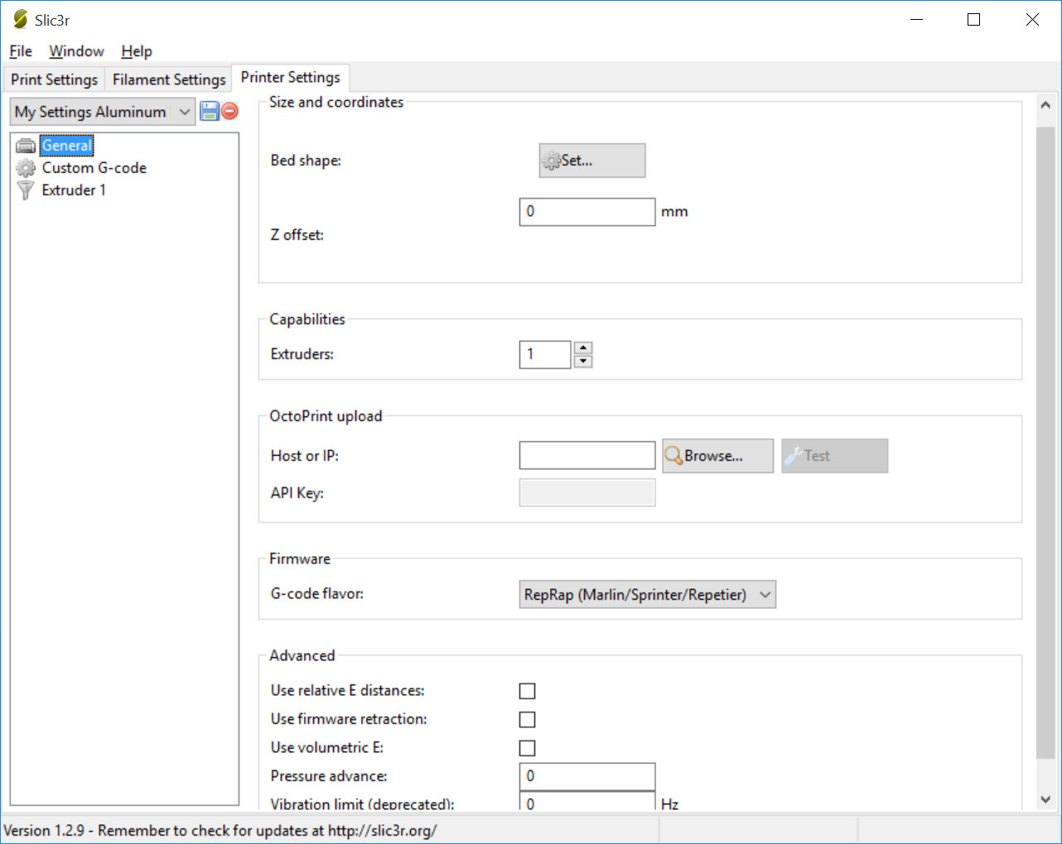

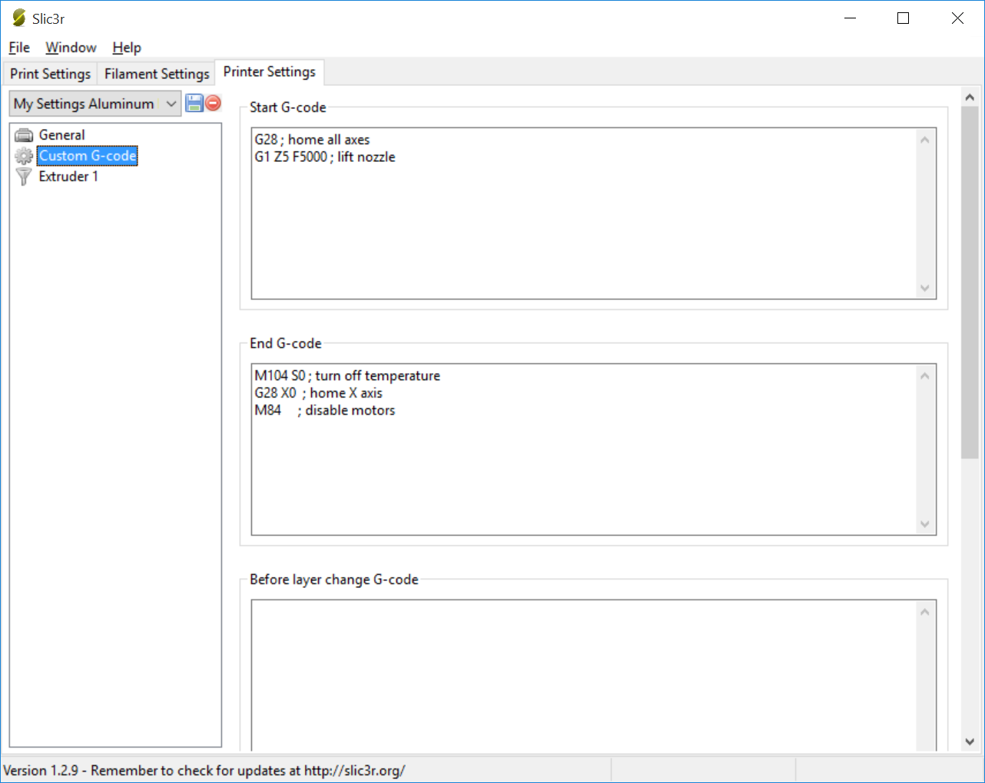

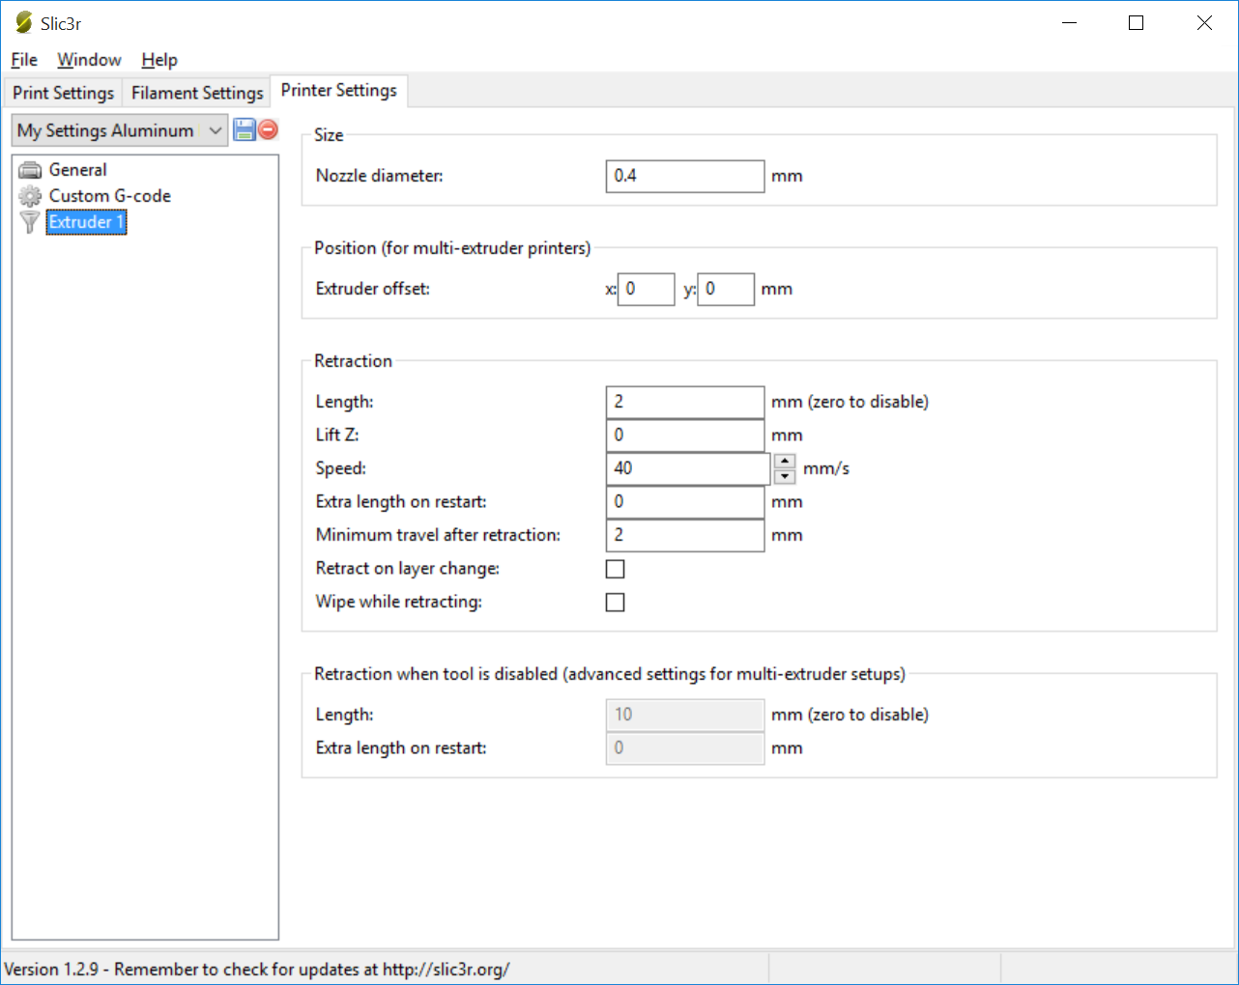

Save these **PRINTER** setting (if you didn’t already)

# Appendix C: MakerBot Settings

## *Important* MakerBot Settings:





